A Technical, Academically Structured Literature Review that maps federal identity doctrine to real-world Microsoft identity infrastructure.
Table of Contents

Federal ICAM Architecture
The U.S. General Services Administration (GSA) publishes the core Federal Identity, Credential, and Access Management (FICAM) architecture. This is the baseline attackers and defenders analyze to understand and identify flows, credential issuance, trust chains, and access enforcement.
Key components you can mine to discover attack paths include, but are not limited to:
- Identity lifecycle (provisioning → maintenance → deprovisioning)
- Credential issuance and revocation (PIV, PKI)
- Federation trust boundaries
- Access control enforcement points
- Approved products list (useful for vendor-specific exploit research)

ICAM in Public Safety & Emergency Response (Federated Identity Weak Points)

CISA ICAM Program
CISA provides extensive ICAM documentation, including:
- ICAM 101 briefing
- ICAM Reference Guide
- Federated ICAM pilot findings
These documents are valuable for:
- Understanding federated identity trust models and frameworks
- Identifying cross-agency authentication weaknesses
- Mapping where identity assertions can be intercepted, replayed, or forged
- Studying how emergency-response systems federate identity under stress (a known attack vector)

Cloud Identity & Zero Trust (Modern Federal ICAM Attack Surface)

Cloud Identity Playbook
This 2026 federal playbook explains how agencies migrate identity services to cloud IDaaS platforms.
Offensive relevance:
- Differences between on-prem IdPs and cloud IDaaS
- Identity automation pipelines (attackers target misconfigured workflows)
- Federation misconfigurations in hybrid environments
- Zero Trust Architecture alignment (NIST SP 800-207)
- Identity governance gaps during cloud migration
This is one of the most useful modern documents for mapping real-world federal identity attack pathways.
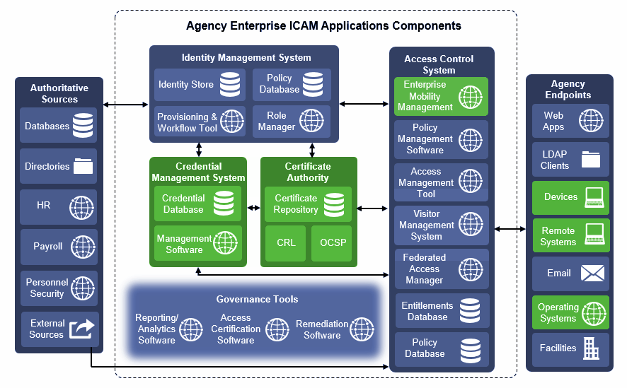
Derived Personal Identity Verification (PIV) Credentials NIST SP 1800-12 (www.nccoe.nist.gov)

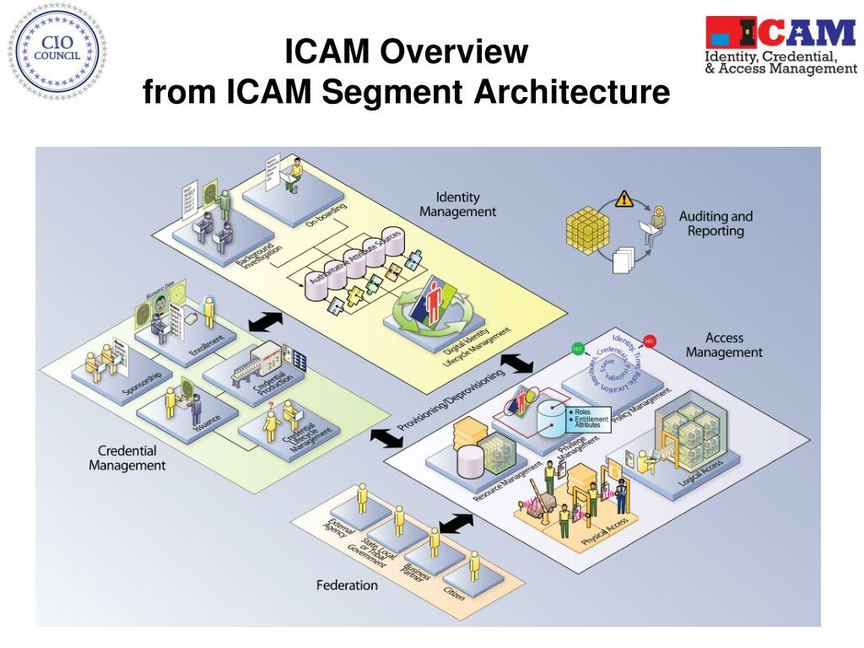
Enhancing Identity and Access Management in Federal Government

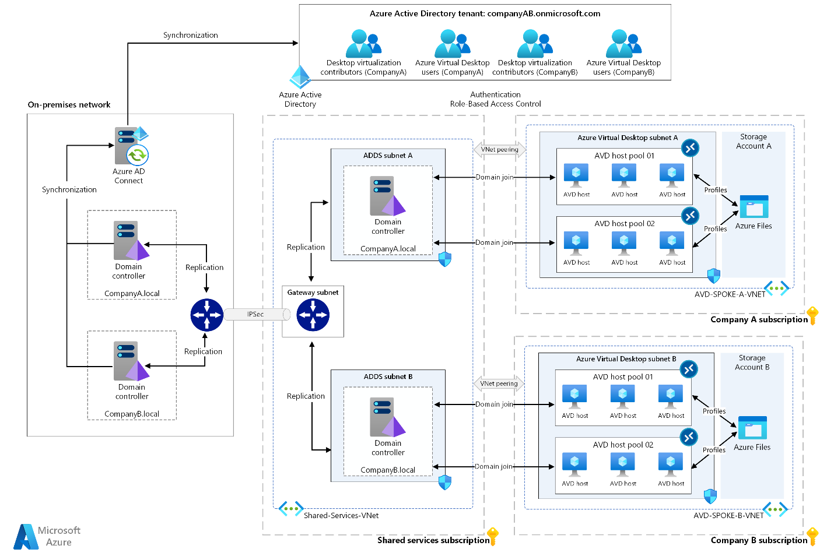
Managing Rules for Dynamic Group Memberships (bamo.kirchner-phot.de)

Federal ICAM: Conceptual Foundations
Federal Identity, Credential, and Access Management (FICAM) is the U.S. government’s standardized identity architecture, maintained by the General Services Administration (GSA) and aligned with NIST SP 800-63, SP 800-157, and Zero Trust (NIST SP 800-207). It defines:
- Identity lifecycle (provision → maintain → revoke)
- Credential types (PIV, derived PKI, PKI certificates)
- Authentication assurance levels
- Federation trust boundaries
- Access control enforcement across agencies
FICAM Architecture (GSA) is the canonical reference for how federal identity systems must be designed, federated, and governed.
Key takeaway: FICAM is a policy and architecture framework, not a product – but it directly shapes how agencies deploy Microsoft AD, AD CS, and AD FS.

Why Microsoft Active Directory is Central to Federal ICAM

1.1 AD as the De-Facto Federal Identity Provider (IdP)
Microsoft Active Directory Domain Services (AD DS) is the most widely used authentication and authorization platform in enterprise and government networks.
Federal agencies rely on AD for:
- User and device identity
- Kerberos authentication
- Group-based authorization
- PKI-based smart card logon (PIV)
- Federation via AD FS
- Certificate lifecycle via AD CS

1.2 ADs Role in FICAM Credentialing
FICAM requires:
- PIV smart card authentication
- PKI trust chains
- Strong credential lifecycle governance
AD natively supports these through:
- Active Directory Certificate Services (AD CS) (certificate issuance, smart card logon, OCSP/CRL)
- Kerberos PKINIT (certificate-based Kerberos)
- Group Policy (enforcement of MFA, credential policies)
Thus, AD is not just compatible with FICAM – it is the operational substrate for most federal ICAM deployments.

2.0 Active Directory Certificate Services (AD CS) in Federal ICAM: PKI as the Attack Surface

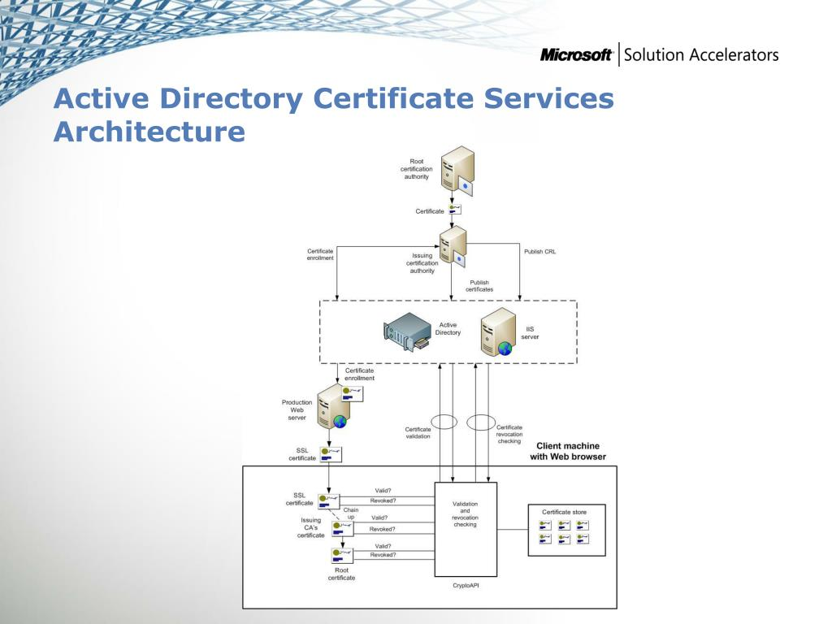
Infrastructure Planning and Design (www.slideserve.com)
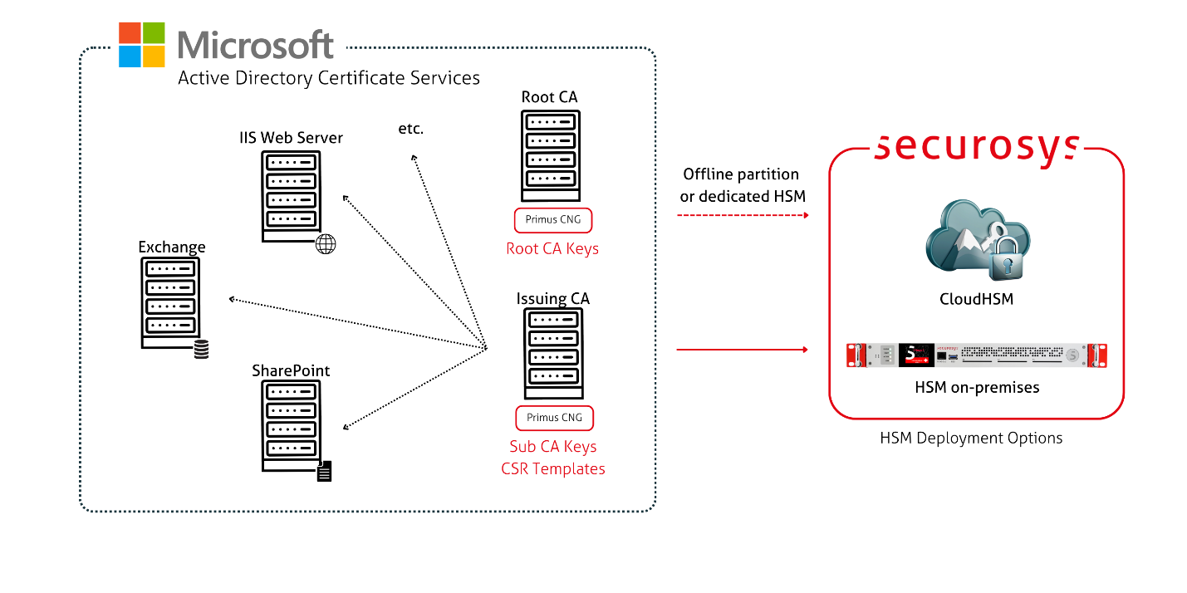
HSM Integration Guide (docs.securosys.com)
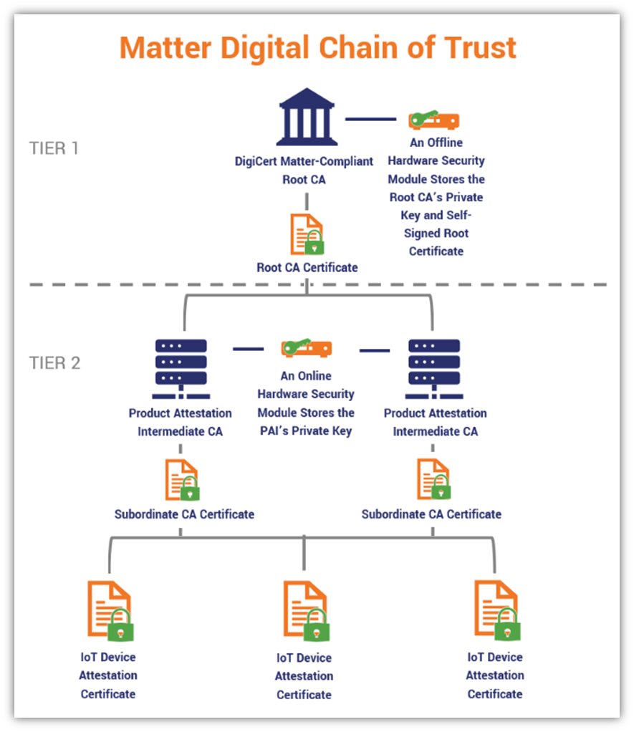
Matter, the New IoT Standard (axnhost.com)
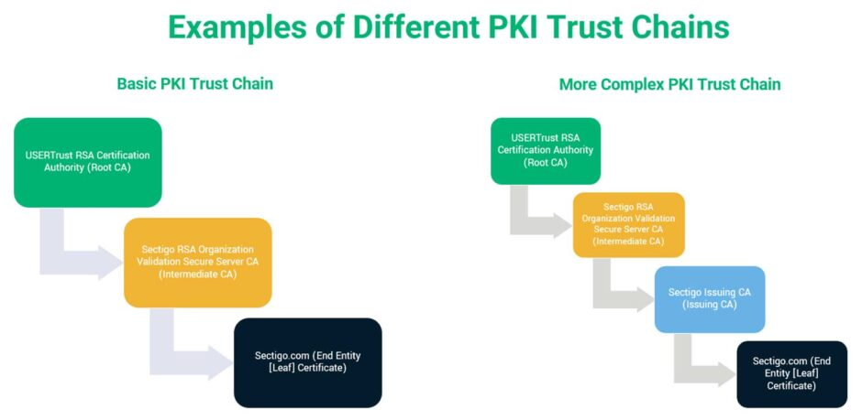
Examples of Different PKI Trust Chains (sectigostore.com)

2.1 AD CS as the Federal PKI Backbone
AD CS provides:
- Certificate Authorities (CAs)
- Smart card logon certificates
- OCSP/CRL infrastructure
- Certificate templates
- Enrollment policies
This aligns directly with FICAMs PKI requirements.

2.2 Literature on AD CS Vulnerabilities
Modern research identifies AD CS as one of the most dangerous attack surfaces in enterprise and government networks:
- Misconfigured certificate templates
- Weak issuance policies
- ESC1-ESC8 escalation pathways
- CA compromise → domain compromise
- PKINIT abuse → Golden Certificates
Federal guidance emphasizes PKI hardening because PKI compromise bypasses all Zero Trust controls.

3.0 Active Directory Federation Services (AD FS) in Federal ICAM: Federation, SAML, and OIDC
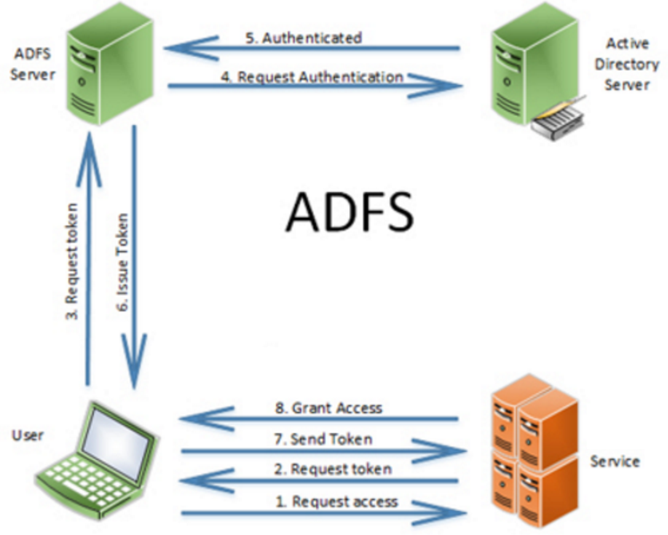
Active Directory Federation Services (www.sherweb.com)
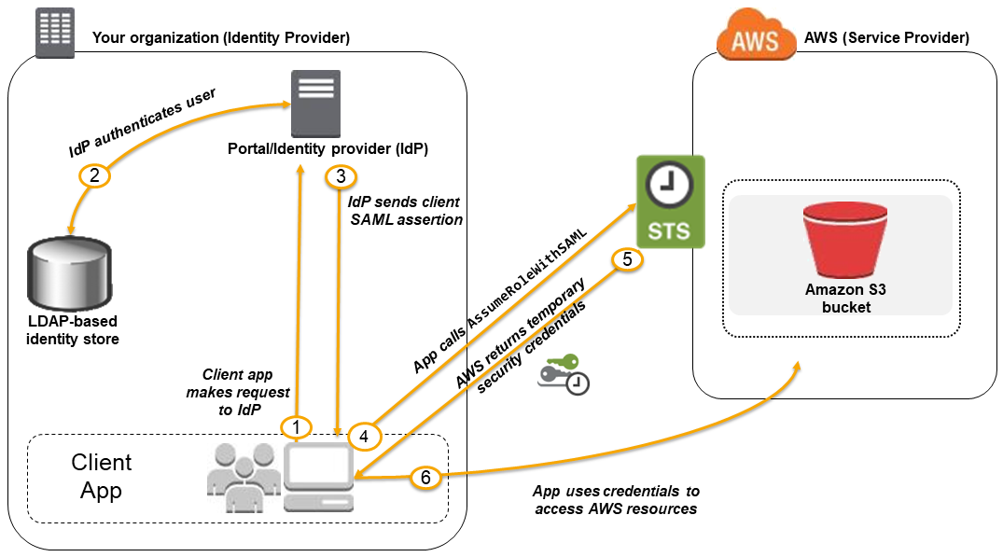
About SAML 2.0-based Federation (doc.aws.amazon.com)
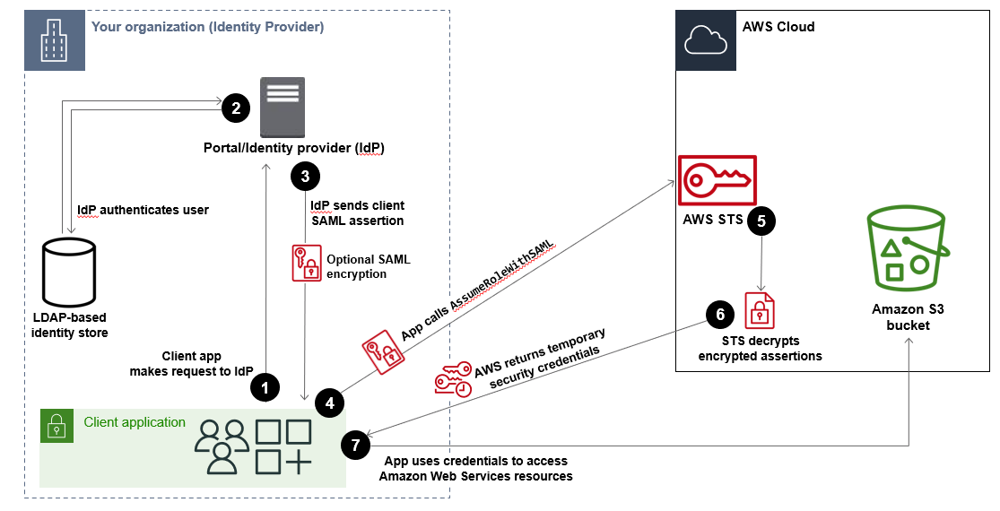
SAML 2.0 Federation – AWS Identity and Access Management (docs.aws.amazon.com)

3.1 Active Directory Federation Services (AD FS) as the Federal Federation Layer
FICAM mandates:
- Cross-agency federation
- Trust frameworks
- Assertion integrity
- Multi-protocol support (SAML, OIDC)
AD FS is the federation engine that enables:
- PIV-based SAML authentication
- OIDC for cloud services
- WS-Trust for legacy systems
- Claims transformation and policy enforcement

3.2 Literature on AD FS Attack Pathways
Federation is a high-value target because:
- Token signing key compromise = total identity compromise
- SAML token forgery attacks
- OIDC misconfigurations
- Replay attacks
- Federation trust pivoting
These are well-documented in federal Zero Trust and ICAM modernization guidance.

4.0 Federal Guidance on AD Security (CISA, NSA, ASD, CCCS, NCSC)

4.1 Joint AD Compromise Guidance (2024)
CISA, NSA, ASD, CCCS, NCSC-NZ, and NCSC-UK released a comprehensive guide on AD compromise techniques.
It documents:
- 17 common AD attack techniques, including:
  - Kerberoasting
  - AS-REP Roasting
  - MachineAccountQuota abuse
  - Unconstrained delegation
  - Credential harvesting
  - Privilege escalation via misconfigurations
- Mitigation strategies, including:
  - Microsoft’s Enterprise Access Model (Tiering)
  - SPN minimization
  - Privileged Access Workstations (PAWs)
  - Hardening domain controllers
  - Reducing legacy protocol exposure

4.2 Relevance to FICAM
Federal ICAM assumes:
- Strong credential governance
- Strong federation trust
- Strong PKI
- Strong identity lifecycle controls

Active Directory’s weaknesses directly overthrow these assumptions.

5.0 Zero Trust and ICAM Modernization
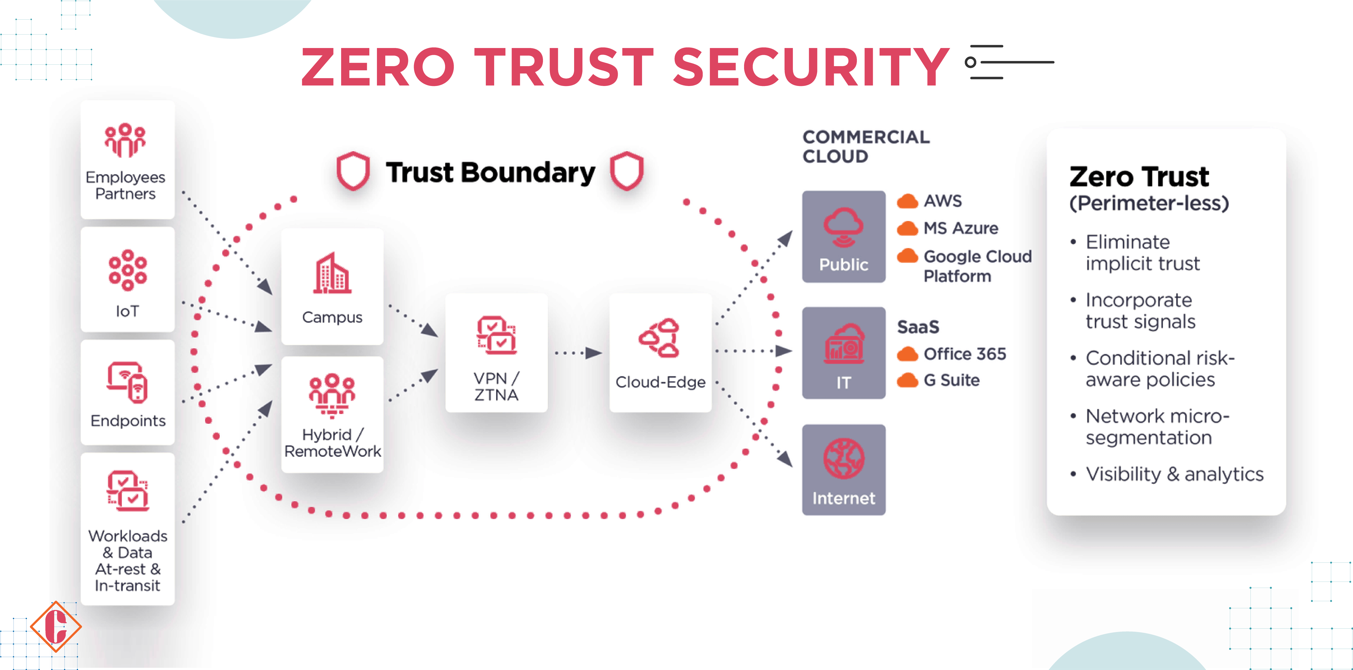
What Is Zero Trust Architecture (fity.club)
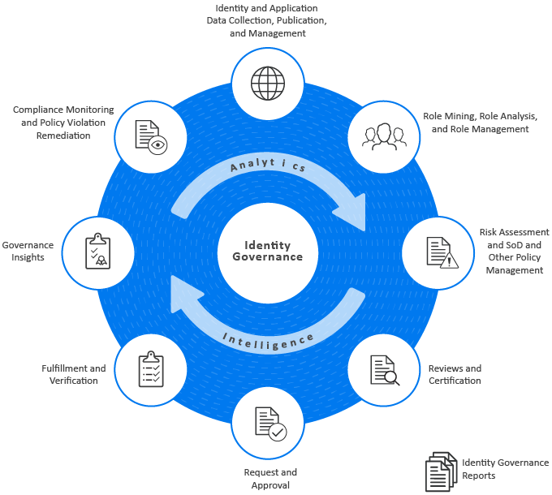
What is Identity Governance and Administration (swatifreelancer.blogspot.com)
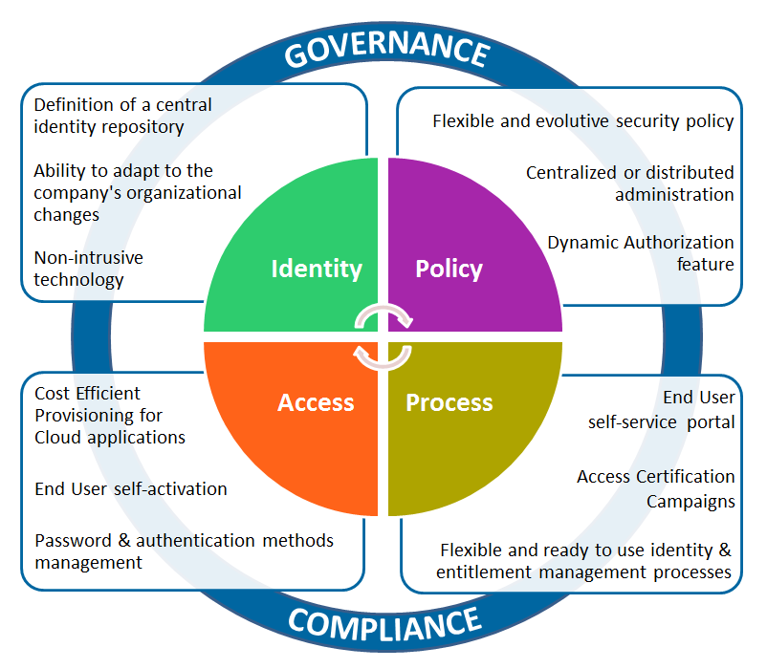
Identity Governance and Administration (evidian.com)
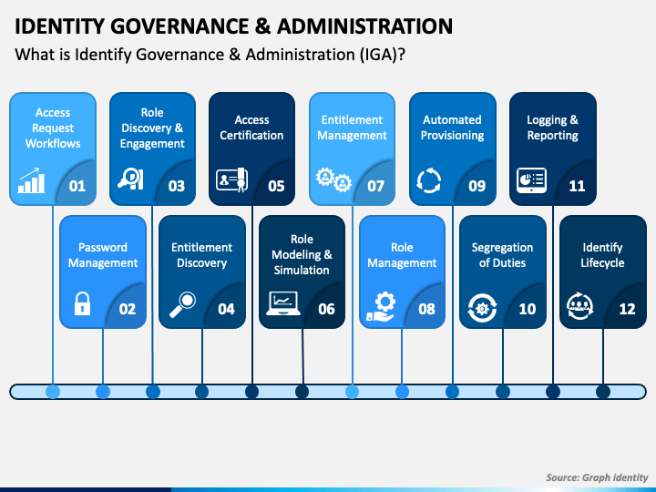
Identity Governance and Administration (IGA)

5.1 NIST SP 800-207 Zero Trust
Zero Trust needs:
- Continuous identity verification
- Device trust
- Strong MFA
- Token integrity
- Identity governance

AD and AD FS must be re-architected to support:
- Conditional access
- Certificate-based authentication
- Token-level inspection
- Identity assurance scoring

5.2 Cloud Identity Playbook (2026)
The federal Cloud Identity Playbook provides guidance on:
- Migrating identity to cloud IDaaS
- Hybrid identity pitfalls
- Federal misconfigurations
- Identity automation pipelines
- SCIM provisioning risks
This is one of the most important modern documents for understanding federal identity attack surfaces.

6.0 Synthesis: How FICAM and AD Interlock

6.1 FICAM Requirements → AD Implementations
FICAM Requirement | AD Component | Security Implications
Strong credentialing | AD CS | PKI compromise = domain compromise
Federation trust | AD FS | Token signing key = crown jewels
Identity lifecycle | AD DS | Stale accounts = lateral movement
Multi-factor auth | PIV + Kerberos PKINIT | Template misconfig = bypass
Access governance | Group Policy + RBAC | Over-permissioning = privilege escalation

6.2 Where Attackers Focus
Attackers target:
- Certificate templates
- CA permissions
- Federation metadata
- Token signing keys
- Kerberos pre-auth settings
- MachineAccountQuota
- Delegation settings
- Legacy protocols

These are the real-world failure points where FICAM doctrine meets AD reality.

7.0 Literature Gaps and Research Opportunities for Book
Your book can fill critical gaps:

7.1 Gap: No unified mapping of FICAM → AD attack paths
Federal documents describe ICAM
Security documents describe AD attacks
No one has mapped them together

7.2 Gap: No offensive/defensive PKI doctrine for AD CS in federal environments
ESC1-ESC8 are not contextualized for FICAM PKI
No one has contextualized the two

7.3 Gap: No Red Team Methodology for attacking federal federation (AD FS)
Token signing key compromise in federal networks is under-documented.

7.4 Gap: No Zero Trust alignment guide for AD DS
Most agencies still run legacy AD.

8.0 Recommended Structure for Book
- Foundations of Federal ICAM
- Microsoft Active Directory as the Federal Identity Backbone
- PKI and AD CS in Federal Credentialing
- Federation and AD FS in Cross-Agency Trust
- Kerberos, PIV, and Certificate-Based Authentication
- Attacking Active Directory in FICAM Environments
- Attacking Active Directory Certificate Services (AD CS) and Federal PKI
- Attacking Active Directory Federation Services (AD FS) and Federation Trusts
- Zero Trust and ICAM Modernization
- Defending FICAM-Aligned Domain Networks
- Blueprint for a Hardened Federal Identity Architecture

What to Research Next
Each of the above documents provides material to explore:
- PIV / PKI Attack Chains
  - Certificate cloning
  - Weak revocation
  - Middleware exploitation
- Federated Identity Attacks
  - SAML token forgery
  - OIDC misconfigurations
  - Trust-boundary pivoting
- Credential Lifecycle Exploitation
  - Onboarding automation abuse
  - Stale accounts
  - Orphaned credentials
- Cloud Identity Takeover
  - IDaaS misconfigurations
  - SCIM abuse
  - Identity-pipeline poisoning
- Zero Trust Bypass Strategies
  - Session token replay
  - Device trust spoofing
  - MFA fatigue in federal contexts
https://www.gsa.gov/technology/government-it-initiatives/federal-identity-credential-and-access-management?utm_source=copilot.com
https://www.cisa.gov/safecom/icam?utm_source=copilot.com
https://www.idmanagement.gov/playbooks/cloud/?utm_source=copilot.com
Explore:
- Offensive ICAM attack chains
- Defensive ICAM hardening strategies
- A Red Team playbook for attacking ICAM
- Chapter 1: Foundations of Federal ICAM
- Chapter 2: Active Directory as Federal Identity Backbone
- Create a full offensive/defensive ICAM-AD attack matrix
https://media.defense.gov/2024/Sep/25/2003553985/-1/-1/0/CTR-DETECTING-AND-MITIGATING-AD-COMPROMISES.PDF?utm_source=copilot.com
Detecting and Mitigating Active Directory Compromises: https://media.defense.gov/2024/Sep/25/2003553985/-1/-1/0/CTR-DETECTING-AND-MITIGATING-AD-COMPROMISES.PDF?utm_source=copilot.com
ASDs ACSC, CISA, and US and International Partner Release Guidance on FICAM: https://www.cisa.gov/news-events/alerts/2024/09/26/asds-acsc-cisa-and-us-and-international-partners-release-guidance-detecting-and-mitigating-active?utm_source=copilot.com
CISA Releases Active Directory Security Guide to Mitigate Cyber Attacks: https://cybersecuritynews.com/active-directory-security-guide/?utm_source=copilot.com
Full Book Outline: Attacking & Defending FICAM-Aligned Active Directory Domains
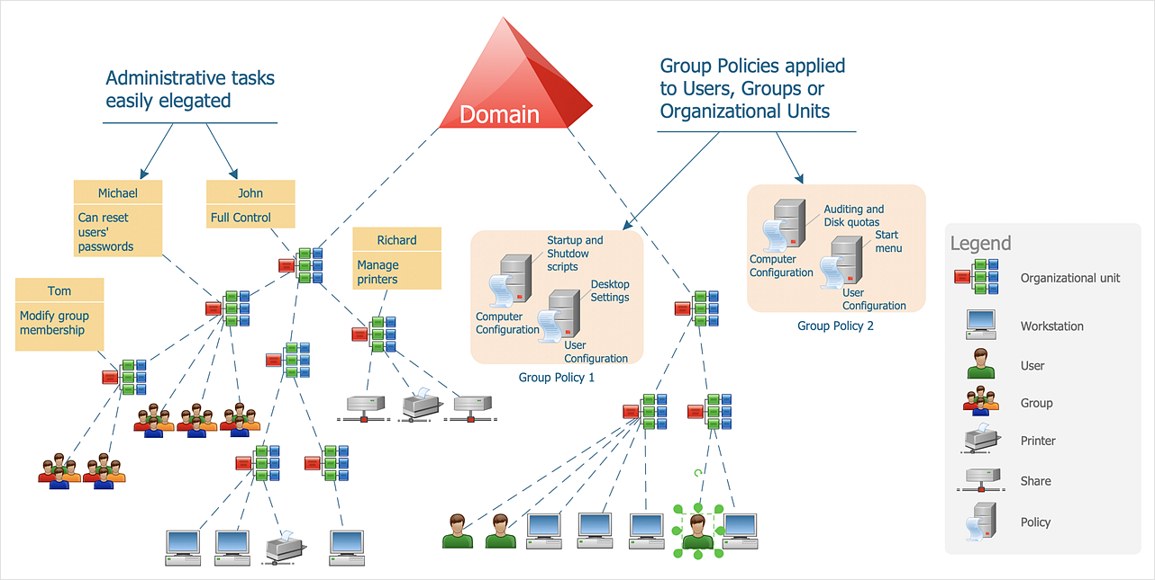
Active Directory Domain Services (www.conceptdraw.com)
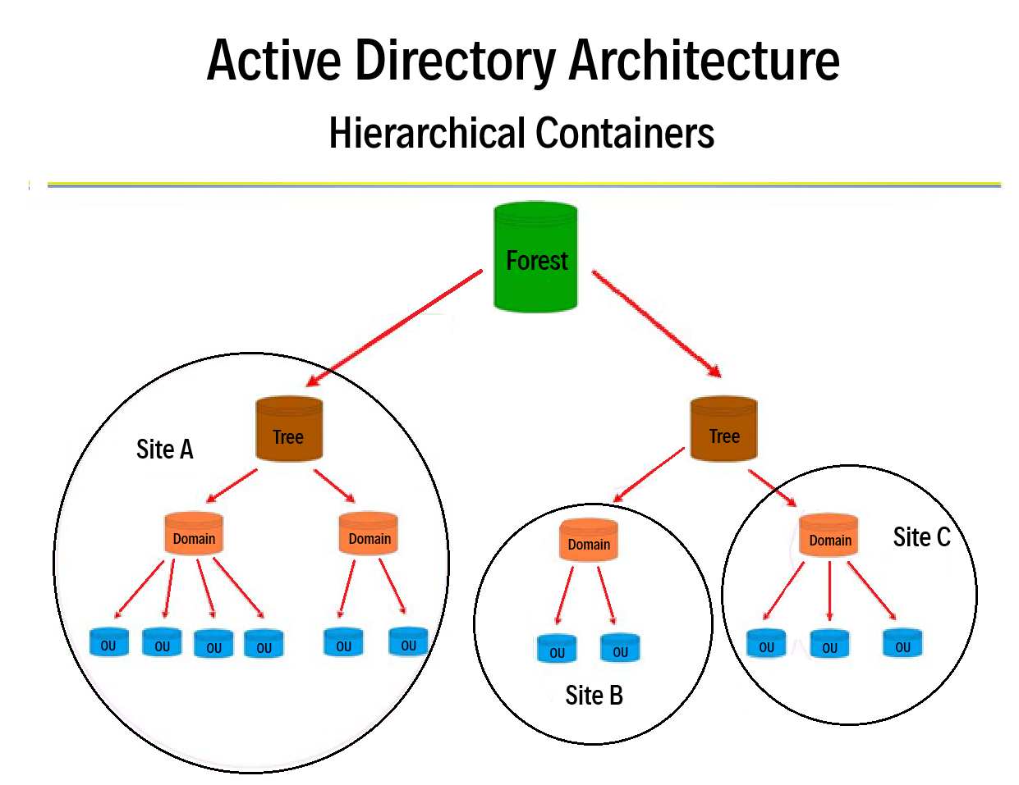
Active Directory Architecture – Hierarchical Container Topology

PART I – FOUNDATIONS (Beginner → Intermediate)
Federal doctrine, identity fundamentals, and network security basics.

Chapter 1 – Federal Information Security Modernization Act (FISMA) Foundations
- Federal Cybersecurity Overview
- FISMA (2002, 2014)
- OMB A-130
- NIST SP 800-37, Revision 2, Risk Management Framework for DoD Information Systems (RMF)
- NIST SP 800-53, Revision 5, ICAM-Relevant Controls
- CNSSI 1253
- CNSSI 4009 (Glossary)
- Homeland Security Presidential Directive-12 (HSPD-12)
- Executive Orders (EOs) Shaping ICAM:
  - EO 13636
  - EO 13800
  - EO 14028
- Federal Zero Trust Strategy: OMB M-22-09

Chapter 2 – Federal ICAM Architecture and Doctrine
- FICAM Architecture
- Identity Lifecycle
- Credential Lifecycle
- Access Lifecycle
- Trust Frameworks
- Federation Requirements
- PIV, Derived PIV, PKI Trust
- ICAM Maturity Model
- ICAM in Zero Trust Network Architecture (ZTNA)

Chapter 3 – Network Security and Ethical Hacking Foundations
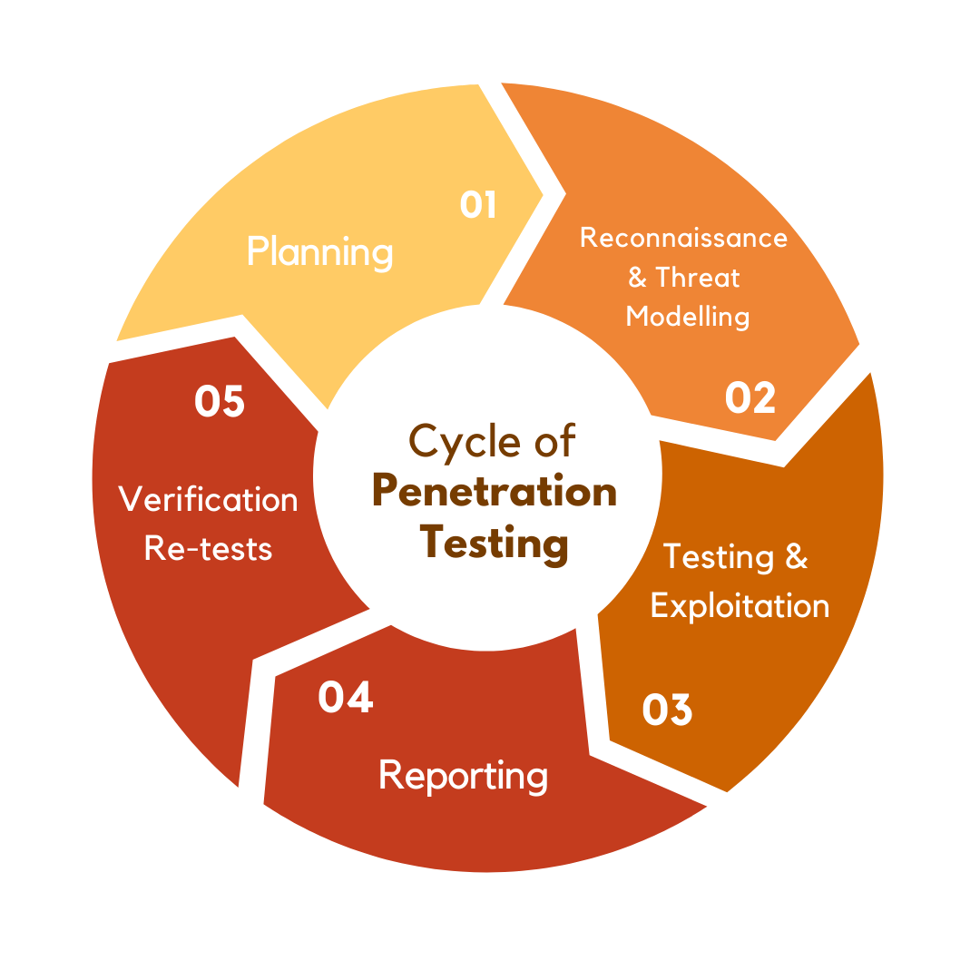
Understanding Penetration Testing: What Is It & the Types (www.privasec.com)
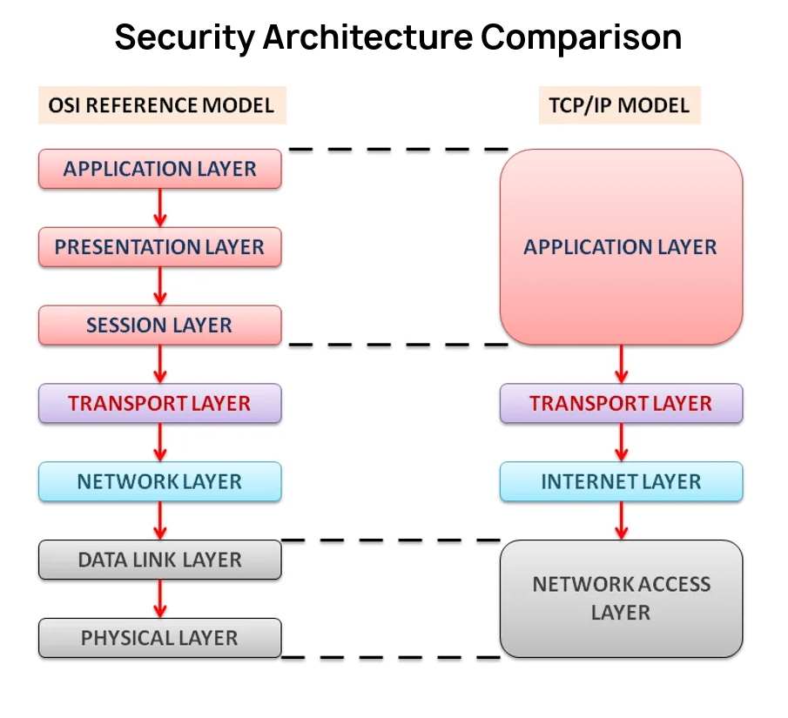
TCP/IP Model vs. OSI Reference Model (www.sanfoundry.com)
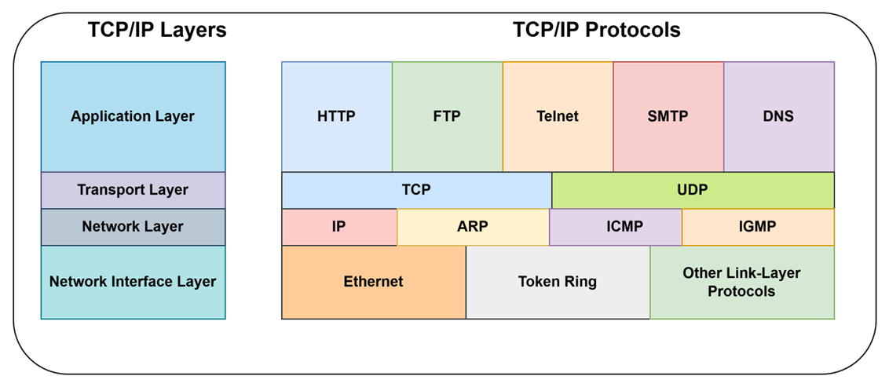
- Ethical Hacking Basics
- TCP/IP, Routing, Segmentation
- Windows Networking Fundamentals
- Penetration Testing Methodologies
  - PTES
  - OSSTMM
  - PTM
- Recon → Exploitation → Post-Exploitation →Reporting
- Federal Rules of Engagement (ROE)
- Legal Boundaries
  - 18 USC 1030
  - CFAA
  - Federal Authorization

PART II – ACTIVE DIRECTORY AS FEDERAL IDENTITY BACKBONE

Chapter 4 – Active Directory Domain Services (AD DS) Deep Dive
- AD DS Fundamentals
- Kerberos (TGT, TGS, PAC, PKINIT)
- LDAP, LDAPS
- Group Policy Object (GPO)
- Domain and Forest Trust Models
- Identity Lifecycle in Active Directory Domains
- Mapping AD DS to FICAM Identity Requirements

Chapter 5 – Active Directory Certificate Services (AD CS) and Federal PKI
- AD CS Architecture
- Certificate Authorities (Root, Subordinate)
- Certificate Templates
- Enrollment Policies
- Smart Card Logon (PIV → AD Mapping)
- OCSP, CRL, AIA/CDP
- PKINIT & Kerberos Certificate Authentication
- Mapping AD CS to FICAM Credential Requirements

Chapter 6 – Active Directory Federation Services (AD FS) in Federal Domains and Networks
- AD FS Federation
- SAML, WS-Trust, OIDC
- Token Signing and Token Decryption Keys
- Claims Issuance
- Federation Metadata
- Cross-Agency Trust Boundaries
- Mapping AD FS to FICAM Federation Requirements

PART III – ATTACKING FICAM-ALIGNED AD DOMAINS (Intermediate → Advanced)

Chapter 7 – Reconnaissance Against Federal Identity Systems
- Identity Reconnaissance Techniques
- Enumerating Active Directory Domain Services (AD DS)
- Enumerating Public Key Infrastructure (PKI)
- Enumerating Federation Endpoints
- Enumerating Identity Governance Systems
- Mapping Reconnaissance Activities to FICAM Identity Flows

Chapter 8 – Attacking Active Directory Domain Services (AD DS) in FICAM-Regulated Environments
- Kerberoasting
- AS-REP Roasting
- MachineAccountQuota Abuse
- Delegation Abuse
  - Unconstrained Delegation
  - Constrained Delegation
  - Resource-Based Constrained Delegation (RBCD)
- SIDHistory Abuse
- DCShadow, DCSync
- Credential Harvesting
- Mapping Each Attack to FICAM Control Failures

Chapter 9 – Attacking Active Directory Certificate Services (AD CS) and Federal PKI Infrastructure
- ESC1 – ESC8 Escalation Pathways
- Certificate Template Misconfigurations
- Certificate Authority (CA) Compromise to Domain Compromise
- Golden Certificates
- PKINIT Abuse
- Smart Card Bypass Techniques
- Mapping PKI Attacks on FICAM Credentialing Weaknesses

Chapter 10 – Attacking Active Directory Federation Services (AD FS) and Federation Trusts
- Token Signing Key Theft
- SAML Token Forgery
- OIDC Misconfigurations
- Replay Attacks
- Federation Trust Pivoting
- Mapping Federation Attacks on FICAM Trust Failures

Chapter 11 – Attacking Identity Governance and Automation
- SCIM Abuse
- Identity Pipeline Poisoning
- Orphaned and Stale Accounts
- Privilege Escalation via Provisioning Workflows
- Mapping Governance Attacks on FICAM Lifecycle Failures

PART IV – DEFENDING FICAM-ALIGNED ACTIVE DIRECTORY DOMAINS (Intermediate → Advanced)

Chapter 12 – Hardening Active Directory Domain Services (AD DS) for Federal ICAM Infrastructure
- Active Directory Hardening
- Microsoft Enterprise Access Model (Tiering)
- PAWs & SAWs: Privileged Access Workstations / Secured Administrative Workstations
- GPO Hardening
- Kerberos Hardening
- Dropping Legacy Authentication Protocols
- Mapping Defenses to FICAM Security Identity Controls

Chapter 13 – Hardening Active Directory Certificate Services (AD CS) and Federal PKI Infrastructure
- Certificate Authority (CA) Isolation
- Certificate Template Governance
- Strong Issuance Policies
- OCSP/CRL Hardening
- Certificate Lifecycle Governance
- Mapping PKI Defenses to FICAM Security Credential Controls

Chapter 14 – Hardening Active Directory Domain Services (AD DS) and Federation
- Token Signing Key Protection
- Metadata Pinning
- Claims Hardening Policy
- OIDC/SAML Hardening
- Mapping Federation Defenses to FICAM Security Trust Controls

Chapter 15 – Zero Trust for Active Directory
- Identity Assurance Scoring
- Continuous Authentication
- Device Trust Integration
- Token-Level Inspection
- Conditional Access
- Mapping Zero Trust to FICAM Modernization

PART V – ADVANCED TOPICS & CASE STUDIES

Chapter 16 – Red Team Playbook for FICAM AD
- Red Team Methodology
- Attack Chains
- Pivoting Across Trust Boundaries
- PKI → AD → Federation Kill Chains
- Report on Federal Audiences

Chapter 17 – Blue Team Playbook for FICAM AD
- Detection Engineering
- Identity Threat Detection
- PKI Monitoring
- Federation Anomaly Detection
- Incident Response for Identity Compromise

Chapter 18 – Case Studies
- Realistic (Fictionalized) Federal ICAM Failures
- PKI Compromise Scenario
- Federation Breach Scenario
- Zero Trust Bypass Scenario
- Lessons Learned

Chapter Drafts (First 3 Chapters Below)

Chapter 1 (Draft): Federal Information Security Foundations

1.1 Introduction
Federal cybersecurity rests on a dense network of laws, policies, directives, and standards. It isn’t a single framework, or a single doctrine, nor is it a product. It is a complex ecosystem shaped by statute, executive authority, interagency coordination, and decades of operational lessons. Agencies don’t secure systems in a vacuum; they work under mandatory requirements that define how identities are issued, how credentials are protected, how access is governed, and how risk is measured.
Before you can meaningfully discuss ICAM or Active Directory security in a federal environment context, you need to first have a clear view of that foundation. The technical controls will only then make sense when you understand the legal and policy structure they’re designed to satisfy, and without that context, any discussion of ICAM or AD security is, therefore, considered incomplete.

1.2 FISMA
The Federal Information Security Modernization Act (FISMA) sets the baseline expectation that every federal agency must run a risk-based security program. That isn’t optional guidance either – it’s a statutory requirement that shapes exactly just how agencies assess threats, manage controls, and justify their security posture to higher management, or auditors and assessors. FISMA also anchors the federal government to NIST (National Institute of Standards and Technology) standards and frameworks, making them the mandatory reference point for everything from system categorization to security control choice.
A central part of FISMAs model is continuous monitoring. Agencies are expected to support near-real-time awareness of their information systems, not rely on periodic check-ins or annual audits. That expectation is what drives the operational tempo of federal cybersecurity and largely influences how identity, credential, and access management programs are designed and evaluated.

1.3 NIST RMF (SP 800-37)
The Risk Management Framework (RMF) provides the federal government with a structured, repeatable way to manage security and privacy risk across the entire system lifecycle. It isn’t just a compliance checklist – it’s the operating rhythm agencies use to understand their mission, evaluate threats, select the right safeguards, and keep trust in the systems that support federal operations.
The RMF is organized into six tightly connected steps, each of which carries identity-related implications:

1. CATEGORIZE
Agencies decide the system’s security impact level based on the potential harm to confidentiality, integrity, and availability. Identity plays an immediate role: the impact level influences how identities must be vetted, how credentials must be protected, and how access must be controlled.

2. SELECT
Agencies choose the proper NIST SP 800-53 security controls based on the system’s categorization. Identity, credential, and access management controls appear across multiple control families – AC, IA, AU, PL, PM, and more – making ICAM one of the most pervasive themes in the selection phase.

3. IMPLEMENT
Technical and procedural controls are put into operation. This is where identity systems take shape: directory services are configured, authentication mechanisms are deployed, credential issuance processes are set up, and access governance workflows are built.

4. ASSESS
Independent assessors evaluate whether the implemented security controls are effective. Identity controls receive heavy scrutiny here:
- Are accounts properly provisioned – more importantly: are they properly deprovisioned?
- Are accounts overly permissioned?
- Are privileged roles tightly governed?
- Are authentication mechanisms resistant to compromise?
- Are audit trails complete and trustworthy?

5. AUTHORIZE
A senior official decides whether the system’s risk posture is acceptable. Identity weaknesses often become the deciding factor in authorization decisions, because ICAM failures directly affect mission risk, insider-threat exposure, and the likelihood of credential misuse.

6. MONITOR
Agencies support continuous awareness of system security. Identity controls are central to this step: account lifecycle events, authentication anomalies, privilege escalations, and credential-related alerts all feed directly into ongoing risk decisions.
Across all six steps, identity is not viewed as a single control – it is a thread that runs through the entire RMF lifecycle. Every phase touches how users are found, how credentials are issued and protected, how access is granted and revoked, and how identity-driven risk is watched over time. In a federal environment, ICAM is inseparable from RMF because identity is inseparable from risk.

1.4 NIST SP 800-53, Revision 5
NIST Special Publication 800-53, Revision 5, acts as the primary federal catalog for security and privacy controls, mandatory for protecting Federal Information Systems (FIS). It sets up mandatory safeguards, technical, and operational security requirements, serving as the technical backbone for the Risk Management Framework (RMF) Select, Implement, and Assess steps. The catalog integrates identity, credential, and access management throughout, particularly within various control families but with specific emphasis placed on the AC, IA, PL, and PM control families.

NIST SP 800-53, REVISION 5 - ACCESS CONTROL (AC) FAMILY
The NIST SP 800-53 Revision 5 AC (Access Control) is a critical security control family that is designed to restrict and govern how system, user, process, and device access is granted, enforced, and revoked. It carries with it 25 base controls, such as:
- Account Management (AC-2)
- Access Enforcement (AC-3)
- Information Flow Enforcement (AC-4)
To protect against unauthorized access, and malicious attacks. Further, it defines expectations for:
- The Principle of Least Privilege
- Separation of Duties
- Role-Based Access Control (RBAC)
- Privileged Account Management (PAM) Restrictions
- Session Controls
- Security Enforcement Mechanisms

Key Components of the AC Family
- Policy and Procedures (AC-1): Sets up, documents, and distributes access control policies.
- Account Management (AC-2): Manage system accounts (creation, modification, deletion) to ensure only authorized users have explicit access.
- Access Enforcement (AC-3): Enforces approved authorizations for logical access to information and system resources.
- Information Flow Enforcement (AC-4): Controls the flow of information within the system and between connected systems.
- Separation of Duties (AC-5): Divides duties to prevent a single individual from having malicious, fraudulent, or mistaken access to information.
- Least Privilege (AC-6): Employs the Principle of Least Privilege to restrict user access to only what is necessary.
- Unsuccessful Logon Attempts (AC-7): Locks out accounts after a set number of failed login attempts.
In practice, AC is where you prove who can do what, under what conditions or circumstances, and with what level of oversight.

TL;DR: NIST SP 800-53 AC Controls
The AC family ensures that organizations can manage their risks by limiting access to their sensitive, high-value assets while supporting secure operational workflows.
AC (Access Control) controls limit what you can do once you are inside.
Who: | Restricts system access to authorized users and devices
How: | Enforces permissions, role-based access, and session timeouts
Why: | Protects sensitive data from unauthorized viewing or modification

NIST SP 800-53, REVISION 5 - IDENTIFICATION & AUTHENTICATION (IA) FAMILY
The NIST SP 800-53, Revision 5 IA (Identification and Authentication) is also a security control family within the SP 800-53 security framework that is designed to ensure that users (both human and non-human) are properly found and verified before accessing federal systems. This control requires that you manage user credentials, enforce password policies that work, and ensure unique identification of each claimant.

Key Components of the IA Family
- Identification and Authentication Policy (IA-1): Develops, documents, and issues policies for finding and authenticating requesting entities.
- User Identification (IA-2): Confirms user authentication requests and verifies that users are individually and uniquely named.
- Authenticator Management (IA-5): Manages passwords, tokens, or biometric factors, including complexity and rotation.
- Re-Authentication (IA-11): Requires re-authenticating users after specific events or time periods.

Common Sub-Controls (IA-x)
- IA-2 (Identification and Authentication): The core control requiring unique user IDs.
- IA-3 (Device Identification): Authenticates specific devices.
- IA-4 (Identifier Management): Manages user identifiers.
- IA-5 (Authenticator Management): Defines requirements for password complexity and life cycle.
IA is the technical core of federal ICAM, ensuring that every identity – human or non-human – is strongly bound to its credentials.
NOTE: The IA family of security controls are mandatory for implementation to remain in compliance with both FISMA and FedRAMP requirements.

TL;DR: NIST SP 800-53 IA Controls
IA (Identification and Authentication) security controls prove who you are before letting you in.
Who: | Gives unique IDs to users, devices, and processes
How: | Enforces passwords, MFA, tokens, and certificates
Why: | Prevents unauthorized access and tracks system activities.

NIST SP 800-53, REVISION 5 - PLANNING (PL) FAMILY
The NIST SP 800-53, Revision 5 PL (Planning) family are a security control family that is designed to ensure that organizations plan, document, and manage their security and privacy strategies in an efficient manner. This control requires that you analyze system risks, document defensive strategies, and secure executive approval before an information system goes live on a production environment.

Key Components of the PL Family
- Policy and Procedures (PL-1): Develops, documents, and issues policies for information system planning.
- System Security and Privacy Plans (PL-2): Requires an exact and complete System Security Plan (SSP) describing system boundaries and security control implementations.
- Rules of Behavior (PL-4): Defines Acceptable Use (AU) policies that all system users must adhere to before access is granted.
- Security and Privacy Architecture (PL-8): Requires documentation of the high-level IT architecture mapped to justifiable business processes.

Common Sub-Controls (PL-x)
- PL-2 (System Security and Privacy Plans): The core control requiring formal approval from an Authorizing Official (AO), or Designated Approving Official (DAO).
- PL-4 (Rules of Behavior): Sets up signed compliance documentation for user accountability.
- PL-10 (Centralized Management): Ensures centralized coordination of planning activities.
- PL-11 (Plan Updates): Mandates continuous updates to the organizational SSP to reflect all major system modifications and updates to network topologies.
PL ensures identity isn’t an ad-hoc technical decision but a planned, governed capability.

TL;DR: NIST SP 800-53 PL Controls
PL (Planning) security controls define how you secure the organization before building or running systems.
Who: | Managed by security officers, privacy teams, and leadership
How: | Mandates system security plans, privacy plans, and architecture rules
Why: | Aligns security strategies with business goals and legal requirements

TO DO: CREATE SYSTEM SECURITY PLAN (SSP) TEMPLATE
DRAFT PL-4 RULES OF BEHAVIOR AGREEMENT

NIST SP 800-53, REVISION 5 – PROGRAM MANAGEMENT (PM) FAMILY
The NIST SP 800-53, Revision 5 PM (Program Management) is a security control family that is designed to manage organization-wide cybersecurity and privacy programs. This control family requires that you implement enterprise-level security tracking, distribute necessary risk management resources, and set up governance structures that are independent of individual information systems, respectively.

Key Components of the PM Family
- Information Security Program Management (PM-1): Develops, documents, and issues enterprise-level security programs and policies.
- Risk Management Strategy (PM-9): Defines the organization’s risk appetite, risk tolerance, risk assessment methodologies, and mitigation strategies.
- Mission/Business Process Definition (PM-11): Maps information systems directly to critical organizational missions and business functions.
- Security and Privacy Workforce: Sets up a strategy to manage and train all personnel holding security roles.

Common Sub-Controls (PM-x):
- PM-1 (Information Security Program Management): The core control requiring an appointed Senior Agency Information Security Officer (SAISO) or Designated Approving Authority (DAA).
- PM-4 (Plan of Action and Milestone (POA&M) Process): Sets up the enterprise-wide process for tracking and correcting security weaknesses. It is also known as a record of accountability.
- PM-5 (System Inventory): Mandates a complete, centrally managed inventory of all organizational information systems, both logical and physical.
- PM-6 (Information System Funding): Ensures security resources and budgets are explicitly tied to enterprise capital planning.
PM is the governance core of federal cybersecurity, ensuring that risk management is executed consistently across the entire enterprise rather than in isolated silos.

TL;DR: NIST SP 800-53 IA Controls
PM (Program Management) security controls manage enterprise risk and security governance across the entire Command.
Who: | Directed by the Chief Information Security Officer (CISO) and executive leadership
How: | Establishes system inventories, budget pipelines, POA&M tracking, and workforce-wide training
Why: | Provides consistent security oversight, structural funding, and compliance alignment to mandatory security regulations and standards

Identity-relevant PM controls ensure that ICAM is coordinated across systems, aligned with federal mandates, and supported by leadership – not left to individual administrators.
Together, these security control families form the structural framework for federal identity security. They define how identities are proved, authenticated, authorized, governed, and watched across the federal enterprise. In Revision 5 of SP 800-53, identity is not treated as a narrow technical function; it is recognized as a foundational element of federal risk management, touching policy, architecture, operations, and continuous monitoring.
TO DO: DESIGN A POA&M
STRUCTURE PM-5 SYSTEM INVENTORY CRITERIA

1.5 CNSSI 1253 and CNSSI 4009
CNSSI 1253: Security Overlays for National Security Systems (NSS)
CNSSI 1253 modifies the standard NIST SP 800-53 security control baselines specifically for National Security Systems (NSS).When designing a Federal Identity, Credential, and Access Management (FICAM) architecture using Active Directory (AD) in an NSS environment, the CNSSI 1253 dictates stricter baseline requirements across Confidentiality, Integrity, and Availability, otherwise known as the CIA Triad.
1.5.1 National Security Systems (NSS)
A National Security System (NSS) is any telecommunications or information system that is owned, or leased, but is operated by the U.S. government (or its supporting contractors) that involves the storage of intelligence, military Command, Control and Communications (C3), cryptology, weapons and ballistics systems, or the processing of classified or CUI information.
These systems are distinct from standard government IT networks and are primarily governed by and enforced by mandatory, strict cybersecurity policies to remain compliant.
1.5.1.1 Key Characteristics of an NSS

1.6 Executive Orders
EO 14028 (Improving the Nation’s Cybersecurity) mandates Zero Trust and modern ICAM.

1.7 OMB A-130
Requires agencies to implement ICAM aligned with FICAM.

Chapter 2 (Draft): Federal ICAM Architecture

2.1 What is ICAM?
Identity, Credential, and Access Management is the federal framework for identity assurance.

2.2 Identity Lifecycle
Provision -> Support -> Revoke

2.3 Credential Lifecycle
PIV Issuance -> certificate lifecycle -> revocation

2.4 Access Lifecycle
Authorization, auditing, enforcement

2.5 Federation
Cross-agency trust using SAML/OIDC.

2.6 ICAM in Zero Trust
Identity is the new perimeter.

Chapter 3 (Draft): Network Security and Ethical Hacking Basics

3.1 Networking Basics
TCP/IP, routing, network segmentation, DNS, SMB, LDAP, Kerberos.

3.2 Ethical Hacking Methodology
Recon -> Exploitation -> Post-Exploitation -> Reporting

3.3 Federal Rules of Engagement (ROE)
Strict authorization, logging, and reporting requirements.

3.4 Tools and Techniques
Nmap, BloodHound, Rubeus, Certipy, Certify, Mimikatz, Impacket Suite
Next:
- Draft the next 3 chapters
- Draft all remaining chapters
- Expand any chapter into full publishable length
- Generate figures/diagrams and descriptions for the book

I asked AI which publisher I should go with considering context of book.
“Here’s the straight, strategic answer you actually need – not generic “self-publishing vs. traditional” fluff. You’re writing a federal-grade, technical, identity-security book that sits at the intersection of:
- Federal ICAM
- Active Directory
- PKI
- Federation
- Zero Trust
- Offensive/Defensive Tradecraft
That is a rare niche, and only a handful of publishers are truly equipped to handle it.

Below is the publisher you should choose, why, and a high-impact pitch written in the tone that gets technical manuscripts accepted.

SPRINGER (via APRESS) is the best fit for your book for five reasons:

- They specialize in advanced technical cybersecurity books
- Apress publishes deep-dive titles on:
- Active Directory security
- PKI
- Identity Governance
- Zero Trust
- Red Team/Blue Team Methodologies
Your book fits their catalog perfectly.

- They publish for both academic and practitioner audiences

Your book blends:
- Federal doctrine
- Identity architecture
- Offensive/Defensive tradecraft
The hybrid style is exactly what Springer/Apress is known for.

- They accept highly technical manuscripts from independent authors
You don’t need a university affiliation or a corporate sponsor.

- They have strong distribution to:
- Federal agencies
- Defense contractors
- Universities
- Cybersecurity training programs and curricula
- Amazon, O’Reilly, Safari, SpringerLink
- They support long, diagram-heavy, reference-dense books.
Your book will likely be around 700-800 pages. Springer handles that effortlessly.

This publisher pitch positions my book as the first and only comprehensive guide to FICAM-aligned Active Directory security.

Publisher Pitch
Master of Your Domain: Attacking and Defending FICAM-Aligned Active Directory Domains and Networks

Working Title
Master of Your Domain: Attacking and Defending FICAM-Aligned Active Directory Domains and Networks

Author
Yvonne A. Silva-Ewry – Cybersecurity practitioner, technical writer, and specialist in identity-centric security architectures.

Overview
This book is the first comprehensive, practitioner-focused guide to securing and attacking Microsoft Active Directory environments aligned with the U.S. Federal Identity, Credential, and Access Management (FICAM) framework. It connects a critical gap that, for many years, has remained just that – a gap between federal identity doctrine and real-world enterprise identity infrastructure by mapping FICAM requirements directly to Active Directory Domain Services (AD DS), Active Directory Certificate Services (AD CS), Active Directory Federation Services (AD FS), and modern Zero Trust identity architectures.
While extensive literature exists in general Active Directory security, no current publication integrates:
- Federal ICAM architecture
- PKI and PIV credentialing
- Federation trust models
- Zero Trust identity requirements
- Offensive and Defensive Tradecraft
- Identity governance and automation risks
This book provides the missing synthesis.

Target Audience
- From Beginner to Advanced Security Practitioners
- Advanced Ethical Hackers
- Federal IT Specialists and Cybersecurity Professionals
- Federal Red and Blue Team Operators
- CCRI/CORI Assessors
- Identity Architects
- Information Systems Administrators
- Students entering identity security roles for the federal government
- Contractors supporting federal agencies
The book assumes no prior federal ICAM knowledge and includes foundational chapters on federal cybersecurity frameworks, CNSSI, Presidential Executive Orders (EOs), from information security to Active Directory to ethical hacking basics.

Key Features
- Full mapping of FICAM identity, credential, and access requirements to Active Directory components
- Deep technical coverage of AD DS, AD CS, AD FS, Kerberos, PKINIT, and certificate-based authentication (PKI/PIV/CAC)
- Offensive tradecraft including AD CS escalation pathways (ESC1-ESC8), federation token forgery, PKINIT abuse, and identity pipeline poisoning
- Defensive strategies and countermeasures with federal Zero Trust mandates
- Case studies illustrating realistic federal identity compromise scenarios
- Over 50 diagrams explaining identity flows, trust boundaries, and attack chains

Why This Book Is Needed
Federal agencies are undergoing rapid modernization of identity systems under OMB M-22-09, EO 14028, and Zero Trust mandates.
However:
- Most federal identity guidance is conceptual, not operational.
- Most Active Directory security books ignore federal ICAM requirements.
- No existing publication unifies PKI, federation AD, and Zero Trust into a single offensive/defensive framework.
This book fills that gap with a structured, technically rigorous, and practitioner-oriented approach.
Estimated Length
700-800 pages
~ 20 chapters
50+ diagrams
Extensive references to NIST, CNSSI, OMB, CISA, DISA, NSA, and other federal publications.
Status
- Full outline complete
- Several chapters drafted
- Research base fully assembled
- Ready to begin manuscript development at once
Conclusion
This book will become the definitive reference for identity-centric security in federal Active Directory domain environments. It is uniquely positioned to serve both practitioners and academic programs focused on cybersecurity, identity management, and Zero Trust architecture.
I welcome the opportunity to discuss this proposal further.

What This Book Is About
Master of Your Domain: Attacking and Defending FICAM-Aligned Active Directory Domains and Networks is a single, practical reference that translates U.S. federal identity doctrine into operational identity security for Microsoft Active Directory (AD) environments. It teaches readers how federal ICAM requirements (PIV, PKI, federation, identity lifecycle, and Zero Trust mandates) map to Active Directory components such as Active Directory Domain Services (AD DS), Active Directory Certificate Services (AD CS), and Active Directory Federation Services (AD FS), and shows, step-by-step, how adversaries exploit gaps, weaknesses, and flaws, and how enterprise defenders identify, contain, eradicate, and mitigate them.
The book is organized to take a reader from foundational federal policy and TCP/IP networking, information security, ethical hacking, and incident response basics through intermediate AD internals and Public Key Infrastructure (PKI), and then into advanced offensive and defensive security principles and tradecraft. Each technical attack chapter is paired with a defense chapter that maps mitigation and remedial strategies directly to FICAM security controls and NIST (National Institute of Standards and Technology) guidance. Case studies and red and blue team playbooks make the material provided actionable and meaningful for federal teams, federal defense contractors, and security practitioners in the federal FICAM AD realm.

Core Promises to the Reader
- Understand federal identity doctrine. Clear, concise primers on FISMA, NIST RMF, NIST SP 800-53, CNSSI, HSPD-12, OMB guidance, and relevant Executive Orders (EOs) so readers know the policy context for every technical decision.
- Master Active Directory as the federal identity substrate. Deep, practical coverage of AD DS, Kerberos, NTLM, LDAP, PKINIT, AD CS, AD FS, PIV, PKI, CAC, ABAC and RBAC, and AAA integration – explained with diagrams alongside insights of real-world examples through real-world experience.
- Learning offensive techniques ethically. Detailed, responsibly framed attack chains (reconnaissance → exploitation → post-compromise) that show how identity systems are abused in federal contexts, with explicit rules of engagement and legal boundaries.
- Build federal-grade defenses. Concrete hardening checklists, detection engineering recipes, and incident response playbooks aligned to FICAM and Zero Trust.
- Bridge policy to practice. Every technical recommendation is tied back to federal security controls and guidance (NIST, CNSSI, OMB, CISA, DISA, NSA), enabling compliance-minded security improvements.
In addition, this book will enable readers to:
- Understand various FICAM-related attacks against Active Directory infrastructure.
- Abuse Active Directory and Windows features like LAPS, gMSA, AD CS, and more.
- Execute and visualize attack pathways used by modern adversaries to breach domain and network perimeters.
- Attack Azure AD Integration (Hybrid Identity).
- Learn MITRE ATT&CK framework TTPs.
- Examine security defenses and their bypasses for JEA, PAW/SAW, LAPS, Selective Authentication, Deception, App Allowlisting.
- Bypass defenses like Windows Defender, Microsoft Defender for Endpoint.

Who This Book Is For
This book is for anyone who is courageous enough to take on the role of an enterprise defender. Beginner to advanced ethical hackers, federal cybersecurity staff, identity architects, red and blue teams, and federal defense contractors who must secure or test FICAM-aligned AD domains and networked environments.

Guide to Zero Trust Architecture for DoD: Building a More Resilient Defense
The landscape of cyber threats targeting the Department of Defense (DoD) is constantly evolving, demanding a paradigm shift in how we secure critical national assets. Traditional perimeter-based security, often described as a "hard shell, soft interior," is no longer sufficient against sophisticated adversaries. Enter Zero Trust Architecture (ZTA) – a strategic cybersecurity model built on the principle of "never trust, always verify."
This guide delves into the essence of Zero Trust for the DoD, explaining its core tenets, implementation strategies, and the benefits it offers in enhancing national security.

Why Zero Trust is Imperative for the DoD
The DoD's vast and complex IT ecosystem, encompassing everything from enterprise networks to battlefield systems and supply chains, presents unique challenges:
- Ubiquitous Remote Access: With a globally distributed workforce and increasing reliance on cloud services, the "network edge" has dissolved.
- Insider Threats: Whether malicious or accidental, insider actions can bypass traditional defenses.
- Sophisticated Adversaries: Nation-state actors and advanced persistent threats (APTs) are adept at exploiting vulnerabilities within seemingly trusted internal networks.
- Operational Technology (OT) Integration: Securing weapon systems and critical infrastructure requires a different approach than traditional IT.
Zero Trust directly addresses these by assuming that no user, device, application, or network segment can be implicitly trusted – regardless of its location or earlier authentication. Every access request is continuously verified.

The Pillars of Zero Trust: DoD Perspective
While the core principles of Zero Trust are universal (defined by NIST SP 800-207), their application within the DoD requires specific consideration.

1. Micro-segmentation: The Granular Approach
Imagine a vast DoD network with hundreds of thousands of devices. Instead of a single, flat network, micro-segmentation divides it into many small, isolated segments. This limits lateral movement for attackers.
- DoD Application: A logistics database might be segmented off from a human resources system. Even if an attacker breaches the HR system, they cannot easily pivot the logistics data without re-authenticating and re-authorizing access. This is crucial for safeguarding Controlled Unclassified Information (CUI) and Classified Information (CI).

2. Identity Governance: Who Are You, Really?
Zero Trust mandates strong, multi-factor authentication (MFA) for every access request, combined with continuous verification of user identity and context.
- DoD Application: Beyond Common Access Cards (CAC), advanced biometrics, behavioral analytics, and continuous monitoring of user activity are becoming essential. This ensures that a user claiming to be "Sgt. Smith" is indeed Sgt. Smith and is behaving within expected parameters.

3. Device Posture and Endpoint Security: What Are You Using?
Every device trying to access DoD resources – whether a government-furnished laptop, a cloud-based server, or an IoT sensor – must be assessed for its security posture.
- DoD Application: Is the device running the latest security patches? Is its anti-malware up to date? Is it encrypted? If a device does not meet the DoD's security baseline, is access denied or significantly restricted?

4. Automated Policy Enforcement & Continuous Monitoring
Zero Trust relies on dynamic policies that adapt to changing conditions and real-time threat intelligence. This requires extensive automation and continuous monitoring of all network traffic and user behavior.
- DoD Application: A sudden surge in data transfer from a typical user, or an attempt to access a highly sensitive file outside of working hours, could trigger an immediate policy review, re-authentication request, or even automatic access revocation. This responsiveness is critical in high-stakes environments.

Implementing Zero Trust for the DoD: A Phased Approach
Transitioning to Zero Trust is not a "rip and replace" operation: it's a journey. The DoD emphasizes a phased, risk-based approach:

1. Identify "Protect Surfaces"
Figure out the most critical data, applications, assets, and services (DAAS) that need protection first.

2. Map Transaction Flows
Understand how users, devices, and applications interact with these protect surfaces.

3. Architect Zero Trust
Design micro-perimeters around protect surfaces and enforce granular access policies.

4. Automate and Orchestrate
Leverage security orchestration, automation, and response (SOAR) platforms to enforce policies dynamically.

5. Continuous Monitoring and Improvement
Zero Trust Architecture (ZTA) functions as a dynamic, evolving security strategy rather than a static deployment. In a fluctuating threat environment, continuous monitoring serves as the operational core of this framework. Security teams and enterprise defenders who are responsible for infrastructure defense depend on a steady stream of telemetry to assess architectural defense effectiveness, and defend mission-critical assets. Modern defense strategies integrate centralized logging and artificial intelligence to analyze behavior patterns across the AD environment. To ensure the principle of “never trust, always verify” remains functional, defenders must maintain complete visibility across all five foundational pillars: identities, devices, networks, applications, and data. This persistent diagnostics process allows defenders and organizations to re-evaluate the security posture of every entity in near-real-time, neutralizing threats that attempt to exploit previously validated access sessions.
Executing Near-Real-Time Adaptation and Threat Response
Building upon comprehensive visibility, defenders and security teams must proactively translate raw telemetry into actionable defense strategies. As new vulnerabilities and adversarial tactics emerge, the arhictecture must ingest fresh threat intelligence to automatically update trust algorithms and access privileges. This operational agility allows information systems to instantly tighten microsegmentation boundaries or enforce step-up authentication the moment risky behavior occurs. By automating these responses, organizations neutralize emerging threats immediately without creating unnecessary friction for legitimate users or disrupting standard business workflows.
Optimizing Policy Governance and Framework Maturity
Effective policy refinement requires a consistent cycle of measurement, review, and improvement. Security leaders must routinely analyze incident response metrics, access logs, and compliance audits to uncover outdated rules, overly permissive policies, and hunt for hidden security blind spots. Treating the architecture as a living framework ensures that access controls tightly align with the principle of least privilege. This ongoing optimization loop successfully balances daily operational requirements with evolving national and international security maturity guidelines.

Challenges and Considerations for the DoD
To secure Active Directory (AD) and Federal Identity, Credential, and Access Management (FICAM) domains within a Department of Defense (DoD) Zero Trust framework, technical engineers, administrators, and ethical hackers must align their strategies with specific federal compliance standards.
Understand that traditional Active Direcotry relies on implicit trust, which creates significant vulnerabilities. To eliminate this risk, defensive architectures must be restructured to enforce strict compliance with federal identity, access, and monitoring guidelines.
- Legacy Systems: Integrating ZTA with decades-old legacy systems is a significant hurdle.
- Scale and Complexity: The sheer size and diversity of the DoD's IT environment make comprehensive ZTA implementation a monumental task.
- Cultural Shift: Moving from implicit trust to continuous verification requires significant cultural and operational changes for military and civilian personnel.
- Funding and Resources: Implementing ZTA demands substantial investment in technology, training, and skilled cybersecurity professionals.

The Future of DoD Cybersecurity with Zero Trust
By adopting Zero Trust, the DoD can strengthen its cyber posture and improve resilience across its environment. Rather than relying on a vulnerable perimeter, it focuses on protecting critical assets wherever they exist, helping preserve national security as threats continue to evolve. This shift is more than a technical modernization effort; it is a strategic necessity for securing the nation’s digital future.

Demystifying STIGs: Securing IT Systems with Compliance and Confidence
In the realm of cybersecurity, adherence to rigorous standards and best practices is paramount to safeguarding sensitive information and supporting the integrity of IT systems. Among the essential tools in the arsenal of cybersecurity professionals are Security Technical Implementation Guides (STIGs). These comprehensive guides, developed by the Defense Information Systems Agency (DISA), provide detailed instructions for securing various technology platforms and software applications. In this blog post, we'll unravel the significance of STIGs and highlight how to help professionals navigate their complexities effectively.

Understanding STIGs: Fortifying Cyber Defenses
STIGs serve as invaluable resources for cybersecurity professionals, offering detailed guidance on securing operating systems, network devices, databases, and applications. They outline configuration settings, security controls, and best practices tailored to specific technology platforms, ensuring compliance with stringent security requirements. By adhering to STIGs, organizations can bolster their cyber defenses, mitigate vulnerabilities, and enhance overall security posture.

The Importance of STIG Compliance
Ensuring STIG compliance is essential for organizations working within the defense sector, government agencies, and any entity handling sensitive or classified information. Non-compliance with STIGs can leave IT systems vulnerable to exploitation, cyberattacks, and regulatory penalties. By implementing STIGs effectively, organizations prove their commitment to cybersecurity, instilling trust among stakeholders and safeguarding critical assets from emerging threats.

Understanding STIG Fundamentals
The Security Technical Implementation Guide, commonly known as STIG, is the “gold standard” for hardening federal Information Technology (IT) assets within highly AD FICAM environments. Created and kept by the Defense Information Systems Agency (DISA), these security hardening guides comprehensive cybersecurity blueprints that benefit not only defenders, but attackers also.
STIG’s primary purpose is to go far beyond out-of-the-box configurations, which are typically designed for ease of use rather than strong security. STIGs set up a rigorous hardening baseline that reduces an organization’s attack surface. By implementing these controls, you apply defense-in-depth and help protect the network, its users, mission goals, and business processes from serious compromise.
The structure of a STIG is defined by its granular approach to risk management and categorizes security requirements into distinct Severity Categories:
- Category I (CAT I) vulnerabilities are the most critical, the most severe, being flaws that could result in immediate loss of confidentiality, integrity, or availability, and presents itself as a grave threat to national security.
- Category II (CAT II) refers to any vulnerable issues that have a high potential to allow unauthorized access.
- Category III (CAT III) covers configurations that have potential to degrade security measures or hinder administrative oversight.
Each individual requirement within a STIG, known as a STIG ID or Check Variant, provides specific technical instructions on how to verify security control settings and the exact steps needed to remediate a non-compliant system.
The application of STIGs is a continuous lifecycle rather than a one-time setup. It begins during the first provisioning of a system, where administrators use tools like the STIG Viewer or automated SCAP (Security Content Automation Protocol) scanners to assess the current state of a device against the DISA requirements. Because applying every single STIG rule can occasionally break the functionality of complex applications, the process often involves a "find, fix, and track" methodology. This requires careful documentation of "open" findings where a security setting cannot be met due to operational necessity, ensuring that the risk is officially acknowledged and mitigated through alternative controls.
In broader practice, STIGs are essential for achieving and supporting an Authority to Operate (ATO) within the Department of Defense and other federal agencies. However, their utility extends far into the private sector and regulated industries like finance and healthcare. By adopting the STIG structure, an IT department shifts from a reactive posture to a proactive one, utilizing a standardized language for security that facilitates audits, simplifies compliance reporting, and creates a uniform defense strategy across a diverse array of technologies, ranging from operating systems and databases to mobile devices and network routers.

Primary Tools for CAT I Vulnerability Discovery and Detection
The following tools are the current standards for identifying STIG non-compliance (CAT I, II, and III):
- SCAP Compliance Checker (SCC): This is the primary automated tool used by the DoD. It is developed by NIWC (Naval Information Warfare Center) and is available to government employees and contractors. It scans the system's configuration and produces an XCCDF or OVAL report, which highlights exactly which STIG checks (like CAT Is) have failed.
- STIG Viewer (and .ckl files): While the STIG Viewer itself is not a "scanner," it is the tool used to open the results of an SCC scan. You import the scan results into a STIG Checklist (.ckl) file. It will automatically mark the "checks" as Open (fail), Closed (pass), or Not Applicable. Any check labeled as Severity: High in the viewer is a CAT I.
- Tenable Nessus / ACAS: In most government networks, the Assured Compliance Assessment Solution (ACAS)—which is based on Tenable Nessus—is the mandated network-based vulnerability scanner. It has specific "audit files" based on DISA STIGs. When you run a compliance scan, it will flag misconfigurations and categorize them by severity, allowing you to see CAT I issues across the entire network from a central console.
- SteelCloud ConfigOS: This is a common commercial tool used for both scanning and automated remediation. It is much faster than manual methods and can identify and "fix" CAT I vulnerabilities across thousands of endpoints simultaneously.
- OpenSCAP: For Linux-heavy environments, OpenSCAP is a popular open-source utility that can parse STIG SCAP content to determine the compliance posture of a local or remote system.

Identifying a CAT I
When looking at the reports generated by these tools, you are looking for:
- Severity: 1 or High
- Vulnerability ID: Often prefixed with "V-"
- Rule ID: Often prefixed with "SV-"
Note: CAT I findings typically require immediate attention and remediation because they pose a direct and immediate threat to the system's security (e.g., a default password or a disabled firewall).

Navigating STIG Documentation
Navigating STIG documentation starts with understanding how DISA standardizes security across various technical platforms. The STIG Compilation serves as a central library of security guides tailored to specific technologies, whether you are working with Windows, Linux, Cisco routers, or SQL databases. To interpret these documents effectively, you must first identify the correct "Benchmark" that matches the specific version of the software in use. Most guides are provided in two formats: an XML-based SCAP file for automated scanning and a human-readable version for manual reviews and policy alignment.
Each STIG requirement is broken down into three main parts: the Rule Title, the Check Content, and the Fix Text. The Rule Title provides the high-level objective—such as "The system must disable the guest account” while the Check Content contains the technical details. This section provides the specific commands, registry paths, or configuration settings required to verify compliance. If a system fails the check, the Fix Text provides the step-by-step instructions needed to remediate the vulnerability and secure the asset.
Implementation methods vary depending on the technology being hardened. For operating systems, the focus is typically on file permissions and audit logs, which are often deployed at scale through Group Policy in Windows or Ansible scripts in Linux. Network devices require a different approach, focusing on disabling unencrypted protocols like Telnet and tightening management access. Applications such as web servers or databases require deep dives into session timeouts, data encryption, and the removal of default sample files that could serve as entry points for an attacker.
The final step in the process is maintaining a STIG Checklist, or .ckl file. This serves as the official record for a specific device, documenting the results of both automated scans and manual reviews. Every finding requires a comment explaining how it was resolved or providing technical justification if the requirement remains open due to operational conflicts. Keeping these checklists updated ensures the security posture is transparent and defensible during a formal audit.

STIG Implementation Best Practices
Implementing STIGs efficiently requires a shift from viewing security as an afterthought to treating it as a core component of the system lifecycle. One of the most effective strategies is the "layered" implementation approach, where configurations are tested in a sandbox environment before being pushed to production. By utilizing a staging environment that mirrors the production setup, administrators can identify which STIG requirements might break specific application dependencies. This methodology allows for the discovery of "operational overrides” cases where a security setting must be modified to keep a mission-critical service running—before those issues cause a live outage.
Automation is the primary driver of efficiency in modern STIG management. Rather than manually configuring every setting, teams use Infrastructure-as-Code (IaC) and configuration management tools like PowerShell Desired State Configuration (DSC), Ansible, or Puppet. These tools allow for the creation of standardized security baselines that can be applied across hundreds of systems simultaneously. Not only does this reduce the man-hours required for implementation, but it also eliminates human error and "configuration drift," ensuring that systems remain compliant long after the initial setup is complete.
To minimize disruptions to IT operations, it is essential to prioritize implementation based on severity and impact. Teams often start with Category I (CAT I) findings, which address the most critical vulnerabilities, while scheduling Category II and III changes during standard maintenance windows. This phased rollout, often combined with "Canary" deployments where updates are pushed to a small subset of systems first, provides a safety net. If a configuration causes an unexpected error, the rollout can be paused and rolled back with minimal impact on the broader organization.
Finally, maintaining a collaborative relationship between security and operations teams is vital for long-term success. STIG implementation should not be a "siloed" activity where security mandates are handed down without context. Instead, documenting successful remediations in a centralized knowledge base—such as a wiki or a documentation tool—helps teams understand the "why" behind specific configurations. This shared knowledge, coupled with regular automated compliance scans, turns STIG maintenance into a predictable, repeatable process rather than a frantic effort leading up to an audit.

STIG Compliance and Auditing
Maintaining STIG compliance is not just about passing a one-time check; it is a fundamental part of an organization’s risk management and continuous monitoring strategy. In many high-security environments, maintaining this compliance is a prerequisite for a system to retain its Authority to Operate (ATO). Beyond the regulatory requirements, consistent adherence to STIGs ensures that the "hardening" of the network remains intact over time. Without regular oversight, systems inevitably suffer from "configuration drift," where routine updates, troubleshooting, or administrative changes slowly erode the security baseline, reopening vulnerabilities that were previously closed.
Conducting a STIG audit begins with a systematic assessment of the environment using both automated and manual methods. The process usually starts with an automated scan using the SCAP Compliance Checker (SCC) or an enterprise tool like ACAS (Tenable Nessus). These tools generate a baseline report that identifies which technical controls are "Open" (non-compliant) or "Not Applicable." However, since automated tools cannot verify every requirement—such as physical security controls or specific administrative policies—auditors must also perform manual "STIGing." This involves logging into systems to verify configurations that require human judgment or checking documentation for non-technical requirements.
The results of these assessments are compiled into a STIG Checklist (.ckl) or an integrated risk management dashboard. During an audit, each open finding must be addressed in a Plan of Action and Milestones (POA&M), which specifies the remediation steps, required resources, and target completion date. If a finding cannot be remediated because of operational requirements, the Authorizing Official must formally accept the risk. This ensures that every deviation from the STIG is identified, documented, and deliberately managed rather than overlooked.
Ultimately, a successful auditing program transforms compliance from a stressful event into a routine business process. By performing "self-assessments" on a regular schedule—monthly or quarterly—organizations can catch and fix non-compliant items before a formal inspection occurs. This proactive approach not only simplifies the audit process but also provides senior leadership with a real-time view of the organization’s security posture. When security teams can demonstrate a high percentage of compliance through verified checklists and up-to-date POA&Ms, they move from a defensive position to one of verified resilience.

Staying Abreast
Studying real-world scenarios highlights that the biggest hurdle in STIG implementation is rarely the technical setting itself, but rather the conflict between rigid security mandates and operational uptime. A common case study involves "Legacy System Fragility," where an organization attempts to apply modern STIGs to an aging, mission-critical application. In one notable instance, a federal agency applied a STIG-mandated TLS 1.2 encryption requirement to its database servers, inadvertently severing the connection to a legacy reporting tool that only supported older, insecure protocols. The solution required a "Technical Jumpstart" approach: instead of leaving the vulnerability open, the team implemented a reverse proxy to handle the modern encryption while isolating the legacy traffic within a micro-segmented, high-security zone.
Another major challenge frequently documented is "Compliance Drift" in large-scale enterprise environments. In a case involving a large defense contractor managing over 10,000 endpoints, manual STIGing led to a compliance rate that hovered around 50% because settings were being reverted during routine troubleshooting. The "Best Practice" solution was the implementation of Desired State Configuration (DSC). By moving to an automated model where security policies were enforced every 30 minutes, the organization reduced its labor hours by over 90% and maintained a consistent compliance rate of 95%. This shift proved that automation is the only sustainable way to manage the sheer volume of checks—sometimes totaling over 300 million across a single enterprise network.
Failed audits, such as the Cyber Operational Readiness Assessment (CORA), often reveal that the breakdown happens in documentation rather than implementation. A real-world example from a Navy-affiliated network showed that while many systems were technically secure, the lack of accurate STIG Checklists (.ckl) and missing Plan of Action and Milestones (POA&M) led to a failed rating. The lesson learned was that "If it isn't documented, it isn't compliant." The solution involved integrating automated scanning tools directly with documentation platforms, ensuring that every scan result automatically populated a checklist with the necessary technical justifications. This transformed the audit process from a frantic, months-long cleanup into a continuous, "always-ready" posture.
Finally, "Application Interoperability" remains a recurring theme in implementation success stories. In a case study involving a web server deployment, applying the full STIG baseline originally broke the application's ability to communicate with external APIs due to strict outbound firewall rules and certificate validation requirements. The successful resolution involved a "Phased Hardening" methodology: applying Category I fixes first in a staging environment, identifying the specific "breaking points," and then documenting official "Risk Acceptances" for those specific settings. This practical insight demonstrates that successful STIG implementation is a balancing act; it requires the technical skill to lock down a system and the operational wisdom to know when a specific control must be tuned to preserve the mission.
Conclusion
In modern cybersecurity, adhering to industry standards is no longer just a best practice – it is the sole baseline for survival. For organizations managing the complexities of heavily regulated FICAM and Active Directory environments, STIGs serve as the definitive framework for hardening systems against threat matrix that expands faster than anyone could ever document it properly. Yet, as we exercise due diligence in checking every box to reach compliance, a deep-rooted question remains: are we building a truly resilient fortress, or are we simply becoming masters of a checklist while the real threat evolves in the spaces between the rules?

The POA&M: The Defender’s Roadmap for Vulnerability Management
There is no denying that in the world of cybersecurity, the stakes remain high, and there is no denying that a Plan of Action and Milestone (POA&M) is more than just a compliance document; it is the primary tactical tool for tracking and mitigating risks (especially CAT Is) that cannot be resolved immediately. When a STIG scan or a manual audit reveals a vulnerability that would break a critical service if “fixed” traditionally, the POA&M now becomes the formal agreement, the accountability record, between security and operations. It serves as a living ledger that identifies the specific weakness, the planned remediation steps, and the hard deadlines for resolution. For a defender, an accurate POA&M is a shield of sorts – it proves that a vulnerability is not being ignored, but is instead being managed through a deliberate, yet delicate, transparent process.
Every effective POA&M is built on three equally important pillars: Identification, Remediation, and Accountability
Identification
This section details the source of vulnerability (such as a STIG ID or a CVE), its severity level (CAT I, II, or III), and the specific systems affected.
Remediation
This is the “Plan of Action” in its most literal sense. It must detail technical milestones – specific, measurable, and realistic steps that will be taken to mitigate the identified risk. Crucially, any modification to the POA&M must be supported by evidence and artifacts. For example, a mid-cycle modification might occur if you are required to tear down and rebuild an entire DMZ (Demilitarized Zone). This is a massive undertaking involving significant time, budget, planning, manpower, and it will almost certainly exceed the standard 30-day remediation window.
In this scenario, if you have replaced two legacy CAT I switches with updated hardware while the broader DMZ rebuild is still underway, you must submit artifacts as validated proof. These artifacts serve as a CYA (Cover Your Ass) of sorts, as they serve as evidence to the SAISO or DAA that new security controls are being implemented and that the organization is actively working toward satisfying the POA&M by tracking and resolving the identified CAT I/CAT II vulnerability findings. This remedial process can take many forms, including developing custom patches, hardware upgrades, the complete teardown of a network segment, or the implementation of a Compensating Control (CC) – such as a more restrictive firewall blocking policy to bridge the gap while waiting for a permanent software or infrastructure upgrade.
Accountability
This defines the “Milestones.” Every action must have a scheduled completion date and an assigned Point of Contact (POC). Without these, a POA&M is merely a list of excuses; with them, it is an enforceable project planned topped with accountability, transparency, and traceability.
Be

Foundations of Active Directory

In Practice: Information Classification Policy
IN PRACTICE:
Section X:
[COMPANY] Information Security Policy
Effective Date’s
Subsection |  |  | Asset Classification & Control |  | Change Control #:
Policy |  |  | Information Asset Classification Policy |  | Approved By:
Objective |  |  | In support of information security, the [COMPANY] will use an asset classification system to determine the protective controls associated with each information asset.
Purpose |  |  | The purpose of this policy is to protect major information assets by providing a mechanism with which custodians and users can readily identify the security and handling requirements of such assets.
Audience |  |  | This policy applies to any individual or organization that has access to or comes in contact with [COMPANY] information assets.
Policy |  |  | The [COMPANY] must adopt and adhere to an information classification system.  All major information assets will be classified and labeled according to [COMPANY] guidelines so that the information asset can be readily identified to determine handling and protection level for that information asset.  The classification system shall remain as simple as is appropriate with a maximum of four classifications, to be easily understood and administered. The classifications will be: Confidential, Sensitive, Restricted, and Public. The criteria for each level will be maintained by and available from the Office of the Information Security Officer.  The asset information owner or their designate shall define the classification of the information.  Each classification has handling and protection rules. The Office of the Information Security Officer is responsible for the development and enforcement of the handling and protection rules.  The classification system will allow classifications of information assets to change over time.
Exceptions |  |  | None
Disciplinary Actions |  |  | Violation of this policy may result in disciplinary action, which may include termination of employment relations in the case of contractors or consultants, or dismissal for interns and volunteers. Additionally, individuals are subject to civile and criminal prosecution.

Active Directory Primer: Guide to Terminology, Definitions and Fundamentals
Before Active Directory existed, there was Novell NetWare Directory Services (NDS), and if you needed to retrieve a shared file in a flat network such as a Novell directory-based network, you would have to know the exact hostname or IP address of the shared server, the path to the file, and its exact name.
Although this solution may work just fine for small- to medium-sized businesses, it is not a feasible solution as a scalable solution for large enterprise networks.
A directory service helps to solve this problem by mapping all the names of networked resources such as shared files, folders, printers, servers, and more, to their IP address.
Today, a directory service like Active Directory Domain Services (AD DS) serves as the primary source for managing directory-related services in large organizational enterprise networks. AD supports almost all mission-critical processes and applications like resource provisioning, capacity planning, security, networking services, resource management, plus more.
In this section, we will examine the essential key terms and concepts that make up the world of Active Directory.
Active Directory Fundamentals
Directory Service
A Directory Service serves as a specialized platform designed to facilitate the organization and retrieval of information about various resources within a network environment. Unlike a traditional database that primarily focuses on data storage and retrieval, a directory service emphasizes the management of data related to network resources, such as users, devices, applications, and services.
The term “object” in this context refers to any identifiable entity within the network that ca be described and managed through the directory service. This includes user accounts, computers, printers, and other resources that can be assigned attributes and properties for easier identification and access.
When we say that a directory service is “more than just a database,” we highlight its functional capabilities beyond mere data storage. While a database typically operates as a static repository where data can be inserted, updated, injected, or deleted, a directory service operates dynamically to enable efficient queries and near-real-time access to information. This functionality is the lifeblood of Active Directory providing an organized and easily navigable network environment for enterprise networks.
The distinction between a directory service and a database lies in their respective roles: the database acts as the underlying storage mechanism, housing the raw data, while the directory service provides a structured interface for interacting with those data sets. It allows you along with applications to perform operations such as searching for specific objects, retrieving their attributes, or managing their relationships within the network.
In sum, directory services are an essential tool for network management, providing a structured and efficient way to store, retrieve, and manage information about network resources, leveraging the capabilities of a database while offering additional services that are tailored to the needs of internal organizational network administration.
Active Directory (AD)
Active Directory (AD) is an expansive directory service that is designed specifically for Windows domain networks. It is an integral component of the Windows Server family of operating systems, particularly when the Active Directory Domain Services (AD DS) role is installed on a member server who is then promoted to a Domain Controller (DC) role. This service plays a key role in managing and organizing information related to users and their associated resources within a network environment.
AD functions by storing data in the form of objects, which are essentially digital representations of various resources within a network. These objects can include user accounts, which contain details about individual users; passwords, which are used for authentication; computers, which represent the devices connected to the network and act as requesting entities for domain-shared resources, and applications, which are software programs that users may access; printers, which provide printing services; file and folder shares, which allow users to access shared data; security groups, which help to manage permissions for multiple users through the management of Organizational Units (OUs) and Group Policy Object (GPO) deployments and enforcements.
The Active Directory services are delivered through a Windows Domain Controller (DC). The DC is both a software and hardware entity that runs the AD DS role and handles providing all the services that are associated with Microsoft Active Directory. One of the primary responsibilities of the domain controller is to authenticate users, ensuring that only those with valid credentials can access the network legitimately. Additionally, it authorizes these users, figuring out what resources they are allowed to access and use within the Windows domain network.
A practical illustration of how Active Directory works occurs when a user tries to sign in to a domain-joined computer. During this process, AD verifies the user’s sent credentials – typically a combination of a username and a password – against its database (ntds.dit).
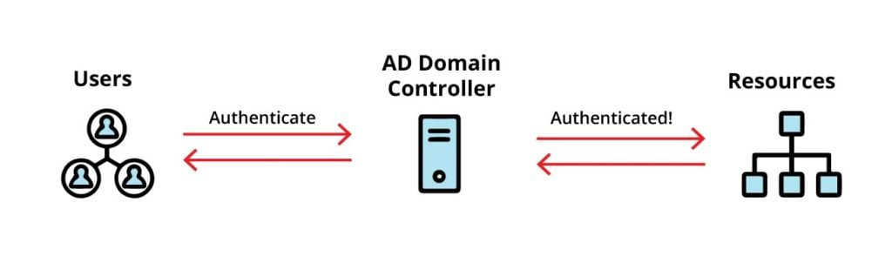
If the provided credentials match those stored in the database, showing that they are valid, the user is granted access to log into the computer and use its resources. This authentication process is vital for supporting security and ensuring that only authorized personnel can access organizational sensitive information, data, and network capabilities.
Lightweight Directory Access Protocol (LDAP)
The Lightweight Directory Access Protocol (LDAP) is an open, vendor-neutral, industry-standard application protocol used for accessing and supporting distributed directory information services over an Internet Protocol (IP) network. Originally developed as a lightweight alternative to the X.500 Directory Access Protocol (DAP), it has become the de facto technology for identity management, authentication, and authorization across enterprise environments.
1. Architectural Framework
LDAP runs on a client-server model. A client (such as an information system, application, or VPN gateway, for example) starts a session by first connecting to an LDAP server (often referred to as a Directory System Agent or DSA). Communication occurs over the TCP/IP stack, and typically uses:
- Port 389: For unencrypted or StartTLS-protected connections.
- Port 636: For LDAP over SSL/TLS (LDAPS).

2. Data Structure and Information Model
Information in LDAP is organized in a hierarchical, tree-like structure known as the Directory Information Tree (DIT). The basic unit of a directory is called an entry, which represent an object, such as a user, group, or hardware device. Each entry consists of attributes, which are key-value pairs (e.g., mail:user@example.com). Attributes are then governed by schemas that define the types of data that can be stored. Each entry has a Distinguished Name (DN), which serves as a unique identifier, acting as a full “path” to the object (e.g., CN=John Doe,OU=Users,dc=example,dc=com). Additionally, the Relative Distinguished Name (RDN) is the specific part of the DN at its current level (e.g., CN=John Doe).
3. Core LDAP Operations
The LDAP protocol defines specific operations for interacting with the directory. These include the Bind operation, used to authenticate a client to an Authenticating Server (AS); the Search operation, which allows clients to retrieve entries based on sorting criteria and filters; Add/Modify/Delete operations, which permit the creation, updating, or removal of directory-related entries; the Compare operation, which checks if an entry contains a specific attribute value without having to retrieve the entire entry; and the Unbind operation, which gracefully terminates the client/server session.
4. Authentication and Security Mechanisms
LDAP provides flexible security layers to protect sensitive identity data. Simple Authentication uses a DN and a password, which can be insecure in plaintext but can be secured using SSL/TLS. The Simple Authentication and Security Layer (SASL) is a framework that allows LDAP to use external authentication mechanisms, such as Kerberos (GSS-API), providing Single Sign-On (SSO) capabilities. Additionally, StartTLS is a command that upgrades an existing insecure connection to a secure one using the Transport Layer Security (TLS) protocol on the same port as LDAP (389).
Microsoft’s Active Directory is the most prevalent implementation of an LDAP-compatible directory service. Active Directory supports both LDAPv2 and v3, although v3 is the current standard, offering better security and extensibility of capabilities and features. Because Active Directory follows established LDAP standards, non-Windows systems (such as Linux, macOS, and Unix) and third-party applications such as firewalls, Content Management Systems (CMS), and HR software can query the Active Directory to authenticate users and verify group memberships. Active Directory also uses LDAP to provide a Global Catalog Service (GCS), typically on ports 3268/3269, allowing for domain forest-wide searches and queries of directory-related objects.
LDAP has numerous use cases, including centralized authentication, which stands as a sole source of truth for user credentials across multiple platforms. It is also used for the Global Address List (GAL), storing organizational contact information for email clients, asset management to track network resources, printers, and shared volumes within a corporate infrastructure, and Role-Based Access Control (RBAC) paired with the Principle of Least Privilege and separation of duties, managing permissions by organizing users into specific LDAP-based groups.
Active Directory Web Services (AD WS)
The Active Directory Web Services (AD WS) is a feature that was first introduced with the Windows Server 2008 R2 operating system. Its primary function is to facilitate the remote management of various Active Directory services. This includes not only local Active Directory domains, which are essential for managing user accounts and resources within an AD-based network, but also Active Directory Lightweight Directory Services (AD LDS) instances.
AD LDS provides directory services without the additional overhead of a full Active Directory domain, making it suitable for applications that require directory functionalities without the need for user or entity-based authentication. Additionally, AD WS supports the management of Active Directory Database Mounting Tool instances, which are used for mounting and managing Active Directory databases.
AD WS operates using the Web Services (WS) protocol, which is a set of standards for exchanging data over a network. It communicates over a specific port, port 9389, which is designated for AD WS-based traffic. This is significant because it means that AD WS is not limited to the commonly used HTTP ports, such as vanilla port 80 for standard web traffic and port 443 for secure web traffic (HTTP/S). By using a dedicated port, AD WS can provide a more secure and efficient means of managing directory-related services remotely without interference from other web services that typically are bandwidth hogs and that operate on the same standard ports.
Active Directory System Agent (AD SA)
An Active Directory instance is made up of its database and a program known as the Directory System Agent (DSA).
The Directory System Agent (DSA) is a key component of the Active Directory architecture. It acts as an intermediary between the directory database and the clients that request information from it. The DSA is responsible for managing and processing requests made by users or applications through the Lightweight Directory Access Protocol (LDAP).
This program, which is a collection of services and processes, gives access to the data store and services that the LDAP requests. The DSA handles various tasks such as authentication, authorization, and directory service operations. It ensures that only authorized users and entities can access specific data and that the data retrieved is accurate, timely, and up to date.
The DSA is the one that provides access to a portion of a directory that has been requested by a Directory User Agent. A Directory User Agent is a client application or service that frequently interacts with the directory infrastructure to perform operations like searching for user accounts, retrieving group membership details, or updating directory entries. The DSA processes these requests, retrieves the necessary information from the directory database, and sends it back to the requesting suer agent, facilitating a seamless interaction for the users in the Active Directory domain environment.
Active Directory Structure
Active Directory (AD) is a directory service developed by Microsoft for Windows domain networks. It plays the most crucial role in managing and organizing network resources in a structured and consistent manner. The logical structure of AD is designed to facilitate the organization and retrieval for network-based resources such as users, computers, groups, and other entities within the network.
At the highest level of the Active Directory hierarchy is the Forest. The forest is positioned within the AD hierarchy as the top-most-level container that holds one or more Trees. Each Tree represents a collection of one or more domains that share a common namespace (CN). Within a Tree, domain can then be organized in a hierarchical fashion, allowing for the efficient management and delegation of administrative and domain-related functional tsks.
Within each domain, there are Organizational Units (OUs). OUs are logical containers used to group common users, groups, computers, and other OUs for easier management, visibility, and administration. They help in applying group policy security enforcements, delegating administrative rights, and organizing resources in a way that reflects the organization’s internal structure.
Overall, the structure of Active Directory is designed to provide a logical framework for managing domain-related resources, making it easier for systems administrators to easily locate and manage network elements based on their given names rather than their physical locations. This logical organization enhances efficiency and simplifies the management of complex network domain hierarchies, enabling organizations to maintain better control and visibility over their IT resources.
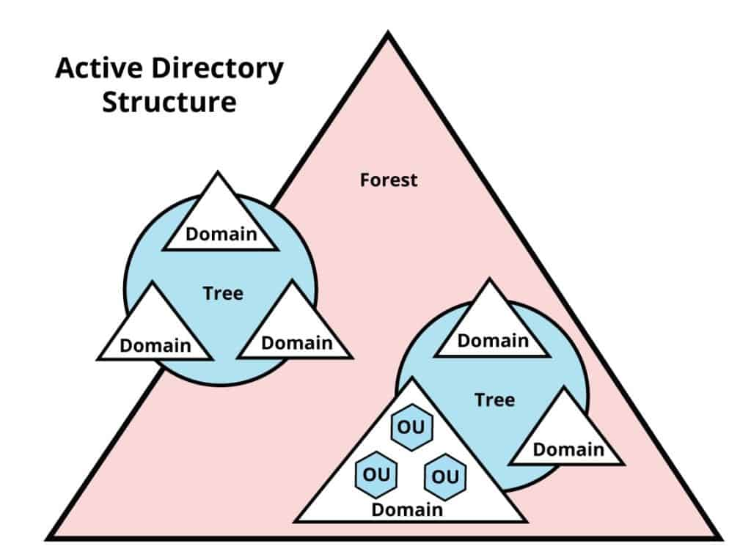
Active Directory Objects
Active Directory domain-related Objects are fundamental components of the Active Directory (AD) system used in Windows environments for managing network resources in an efficient and consistent manner.
Active Directory is a directory service developed by Microsoft that provides a variety of services for network management, including user authentication, resource management and allocation, and security of identity, credential, and access management.
In an Active Directory domain, an object is a distinct entity within the domain hierarchy that represents various items or entities in the domain network. These objects can range from user accounts, which represent individual users within an organization, to computer accounts that represent devices connected to the organization’s network. Each object is characterized by a collection of attributes that provide detailed information about it. For instance, a user object might include attributes such as the user’s full name, unique identification number, email address, physical address, telephone number, and other relevant identifying details that define that individual user within the domain network.
Active Directory categorizes these objects into two main types:
1. Resources
This category includes objects that represent shared resources on the domain network, such as printers, computers, and other devices that users can access or utilize. These objects are necessary for enabling collaboration and sharing of resources among users in a networked domain environment.
2. Security Principals
This category encompasses objects that require authentication and authorization to access network resources. It includes user accounts, groups of users, and security-related items like passwords and password hashes. Each of these security principal objects is assigned a unique Security Identifier (SID), which is a necessary component for managing permissions and access control within the domain. The SID serves as a unique key that the AD system uses to identify the security principle; and determine whether it holds the rights to access specific resources or to perform certain actions within the network.
Overall, Active Directory objects play a critical role in managing and securing a network by providing administrators with a structured way to represent and control access to various entities within the networked information systems.
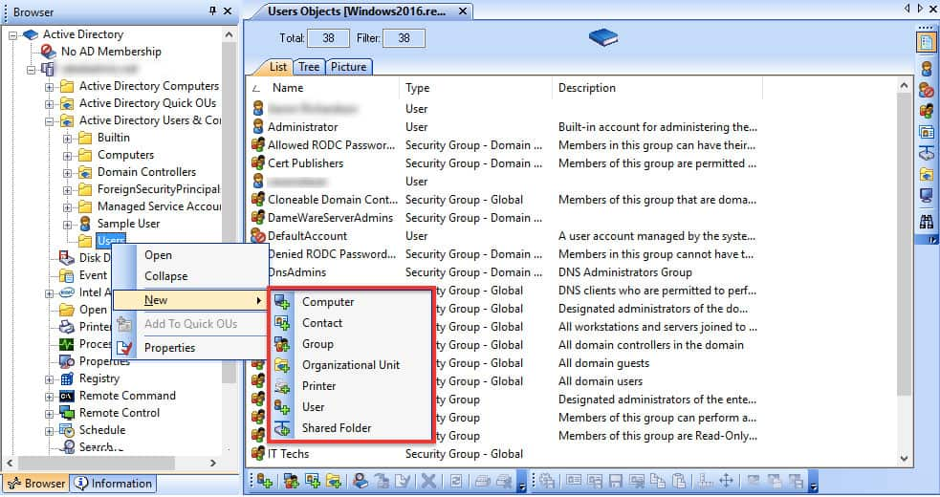
Objects Supported by Active Directory
Users: User accounts are essential components of Active Directory, as they are created for individuals who require access to various resources within the domain. Each user account is uniquely identified by a username, which serves as the account's identifier, and a password, which secures the account and ensures that only authorized individuals can access the resources associated with it. User accounts can also be assigned specific permissions and rights, allowing for tailored access to different parts of the network based on the user's role or responsibilities.
Computers: In Active Directory, computer objects represent devices such as workstations and servers that are part of the domain. Each computer object is registered in the directory, enabling administrators to manage and monitor these devices effectively. This includes applying security policies, deploying software, and ensuring compliance with organizational standards. Computer accounts are crucial for establishing trust relationships within the domain and facilitating secure communication between devices.
Contacts: Contact objects in Active Directory are used to store information about individuals or entities that are not part of the domain but may need to be referenced by domain users. These could include external vendors, partners, or customers. Unlike user accounts, contacts do not have a Security Identifier (SID) and therefore do not have the same level of access rights within the domain. They serve primarily as a means of maintaining an address book or directory of external parties that users may need to communicate with.
Groups: Groups in Active Directory are collections of user accounts, computer accounts, or contacts that are grouped together to simplify management and administration. There are two primary types of groups: Security groups, which are used to assign permissions to shared resources, and Distribution groups, which are primarily used for email distribution lists. By organizing users into groups, administrators can efficiently manage permissions and access rights, making it easier to apply changes across multiple accounts simultaneously.
Shared folder: A shared folder in Active Directory refers to a specific directory on a server that has been configured to allow multiple users to access its contents over the network. This object is crucial for collaboration, as it enables users to share files and documents easily. Administrators can set permissions on shared folders to control who can view or modify the contents, ensuring that sensitive information is protected while still allowing necessary access for collaboration.
Printer: Printer objects in Active Directory represent shared printers that are available to users within the domain. These objects allow for centralized management of printer settings and permissions, making it easier for users to find and connect to printers on the network. Administrators can configure printer properties, manage print queues, and control access to printers based on user roles or departments.
Organizational Unit (OU): An Organizational Unit (OU) is a container object within Active Directory that can hold other objects such as users, computers, groups, and even other OUs. OUs help organize these objects into a hierarchical structure that reflects the organization’s structure or functional areas. This organization facilitates easier management by allowing administrators to apply group policies and permissions at the OU level, impacting all objects contained simultaneously. OUs also help in delegating administrative tasks by allowing specific permissions to be assigned to different administrators for managing various OUs without granting them full control over the entire domain.
Organizational Units (OUs) vs. Groups
Organizational Units (OUs) and Groups are two distinct concepts within directory services, particularly in environments such as Active Directory. Understanding the differences between them is crucial for effective management and organization of resources.
Object Groups: Groups are primarily utilized for managing permissions and access control to resources within a network. They serve as collections of user accounts, computer accounts, or other groups, allowing administrators to assign rights and permissions collectively rather than individually. This means that when a user is added to a group, they inherit the permissions associated with that group, which simplifies the process of managing access to files, folders, applications, and other network resources. Groups can have Security Identifiers (SIDs), which are unique identifiers assigned to each group that help in enforcing security policies. This allows for fine-grained control over who can access what within the network.
Organizational Units (OUs): In contrast, Organizational Units are primarily designed for the purpose of organizing objects within a directory. OUs serve as containers that can hold users, groups, computers, and other OUs, allowing for a hierarchical structure that reflects the organization’s structure. They are mainly utilized for applying Group Policies (GPOs) and managing permissions at a higher level. For example, an administrator can apply specific policies to all users within an OU without affecting users outside of it. Unlike groups, OUs do not have SIDs and cannot be nested within groups. This means that while they can be used to manage and delegate administrative tasks, they do not serve the same purpose as groups in terms of access control.
In summary, while both Object Groups and Organizational Units play critical roles in network management, their purposes are distinct: groups focus on access control through permissions and SIDs, while OUs are focused on organization and policy application without SIDs. Understanding these differences helps administrators effectively manage resources and enforce security within their networks.
User Naming Attributes
User naming attributes in Active Directory (AD) identify and manage domain-joined user accounts Each of these attributes have specific responsibilities they are designated to handle, such as:
1. UserPrincipalName (UPN)
The UserPrincipalName (UPN) is the primary logon name for a user in Active Directory. It typically follows the format of an email address (e.g., user@example.com), making it easier for users to remember and use. The UPN is especially useful in environments where users need to log in to multiple services or applications, as it provides a consistent identity across different platform environments.
2. ObjectGUID
This attribute stands for Object Globally Unique Identifier. It acts as a unique identifier for each user object in Active Directory. The ObjectGUID is generated when the user is created and remains unchanged throughout the object's lifecycle, even if the user account is deleted and recreated. This uniqueness ensures that every user can be distinctly identified, which is essential for security and management purposes.
3. sAMAccountName
The Security Account Manager (SAM) Account Name is a legacy logon name that was used in earlier versions of Windows (prior to Windows 2000). It is still supported for backward compatibility with older systems. The SAMAccountName is limited to 20 characters and is often used in scenarios where older applications or systems require this format for authentication.

4. Object Security Identifier (ObjectSID)
The Object Security Identifier (SID) is a unique value that identifies a user or group within Active Directory. The ObjectSID is crucial for security operations, as it is used by the system to determine user permissions and group memberships. When a user logs into a system, their SID is checked against the permissions assigned to resources, ensuring that only authorized users can access certain files or applications.

Security Identifier (sIDHistory)
This attribute stores previous SIDs associated with a user object. It is particularly useful during migrations or when users are moved between domains. By retaining SIDHistory, organizations can ensure that users retain access to resources that were previously assigned to them, even if their primary SID has changed due to domain transitions.
These naming attributes collectively enhance security and manageability in Active Directory by providing unique identifiers and facilitating user authentication across various systems and applications.

Active Directory Domains and Supporting Components
In an Active Directory (AD) network, a domain serves as the fundamental organizational unit that encapsulates a set of network resources such as user accounts, computers, groups, and other objects. These resources are managed collectively within the domain, and they share a common database that maintains their identities and attributes. Each object within the domain is uniquely identified by an object ID, which is crucial for the management and retrieval of these resources.

Active Directory Subdomains / Child Domains
A domain can also have hierarchical structures known as sub-domains or child domains. These child domains allow for a more organized approach to managing resources, especially in larger organizations where different departments or geographical locations may require their own distinct sets of policies and permissions while still being part of the overarching domain structure.

Client-Server Communications Model
The client-server communication model employed by domains is essential for maintaining security and control over resources. In this model, the domain acts as a server that provides various services to clients, which can be individual users or groups. This setup allows for centralized management of security permissions. For instance, administrators can assign specific rights and access levels to users or groups from the domain level, ensuring that only authorized individuals can access sensitive information or resources.

Active Directory Domain Controllers (DCs)
Moreover, the domain controller (DC) plays a pivotal role in this architecture. It is a server that hosts the Active Directory database and is responsible for enforcing security policies within the domain. The domain controller utilizes various security services to authenticate users and authorize their access to resources based on predefined permissions. This ensures that only users with the appropriate credentials can perform certain actions or access specific data, thereby enhancing the overall security framework of the organization.
In summary, domains in Active Directory are essential for organizing and managing resources efficiently while providing a robust security model that safeguards sensitive information through structured permissions and authentication processes.
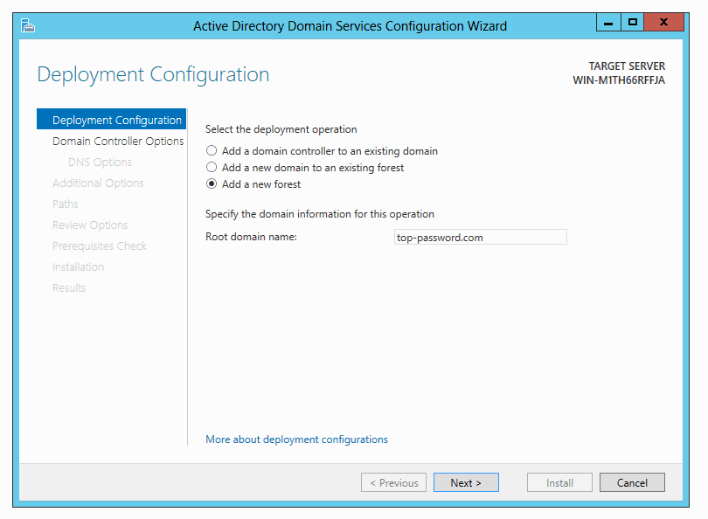

Common Characteristics of an Active Directory Domain

A Group of Domains Makes Up a Tree
In Active Directory, a tree is a collection of one or more domains that share a contiguous namespace. This means that all domains in a tree are connected to a hierarchical structure, where each domain can contain subdomains. For example, if you have a root domain like "company.com," you could have subdomains such as "sales.company.com" and "hr.company.com." This hierarchical organization helps in managing resources and policies across different departments or units within an organization.

Configuring Group Policy for an Entire Domain
However, it is more common to apply it to an OU. Group Policy is a feature in Active Directory that allows administrators to define specific configurations for users and computers within the network. While it is possible to apply Group Policy settings at the domain level, it is often more practical to apply them to Organizational Units (OUs). OUs are logical directory tree containers within AD that can hold users, groups, computers, and other OUs. By applying Group Policies at the OU level, administrators can tailor settings to specific groups or departments, ensuring that policies are relevant and effective for the users and resources within that OU.

Identifying AD Domain Names and Subdomains with Doman Name Server (DNS)
Active Directory relies heavily on DNS for naming and locating resources within the network. Each AD domain is associated with a DNS name, which provides a way to identify and access resources. A DNS name typically follows a hierarchical structure like that of the AD domain itself. Additionally, sub-domains can be created under a main domain, allowing for further organization and management of resources. For example, if "company.com" is the main domain, "support.company.com" could serve as a sub-domain specifically for support-related resources.

Creating a Root Domain Name for the First Time
The root domain is the top-most-level domain in an Active Directory hierarchy. When setting up Active Directory for the first time, administrators must define this root domain name, which serves as the foundation for the entire directory structure. The root domain name is crucial because it establishes the namespace for all subsequent domains and OUs. Choosing an appropriate root domain name is important as it reflects the organization’s identity and can influence how users interact with the directory.

Active Directory Domain Name Examples
An example of an Active Directory domain name would be “ad-internal.company.com,” where “ad-internal” is the name you are using for your internal AD domain, and “company.com” is the name of your external resources: In this example, "ad-internal" represents the specific name chosen for the internal Active Directory domain, indicating that it is meant for internal use within the organization. The "company.com" portion represents the organization's external domain name, which is used for public-facing resources such as websites or email services. This structure helps differentiate between internal network resources managed by Active Directory and external resources accessible over the internet.
Overall, understanding these characteristics of Active Directory domains is essential for effective management and configuration of network resources within an organization.

Fully Qualified Domain Name (FQDN)
The Fully Qualified Domain Name (FQDN) is an important component in the realm of networking and internet addressing as it serves as a complete and unambiguous identifier for a specific host or computer within a domain. FQDN provides a way to precisely locate a device in the expanse of the internet or within a private network.
An FQDN is composed primarily of two parts: the hostname and the domain name. The hostname refers to the specific name assigned to the individual device, while the domain name represents the broader network or organization to which that device belongs. Together, these elements create a unique address that ensures that no two devices can have the same FQDN within the same domain.
For instance, consider a scenario where there is a computer designated as “WORKSTATION-040” within the domain “sales-internal.company.com.” The FQDN for this computer would be structured as “WORKSTATION-404.sales-internal.company.com.” This format clearly indicates that “WORKSTATION-040” is a host operating under the “sales-internal” subdomain, which is part of the larger parent “company.com” domain.
In summary, the FQDN is essential for maintaining secure communications and data transfers over networks, as it provides a clear and distinct way to identify domain-connected devices, ensuring that user and entity-based requests are directed to the correct corresponding location without ambiguity or confusion.

Active Directory Trees
An Active Directory Tree is a structured arrangement of multiple domains that are part of an Active Directory network. Each domain within the tree shares a common Domain Name System (DNS) naming structure, or common namespace, which means that they follow a consistent naming convention that allows for easier management and organization.
The concept of an Active Directory Tree refers to the hierarchical nature of the domains. In an AD Tree, each domain has exactly only parent domain, which establishes a clear parent-child-like relationship among the parenting, Top-Level Domains (TLDs). This hierarchy resembles a tree-like structure, where ethe top-level domain can be thought of as the trunk, and the subsequent child domains branch out from it. This organization aids you in creating logical security boundaries between different interconnected domains and subdomains, allowing for better control and management of resources, security settings, and administrative tasks.
Additionally, when multiple Active Directory Trees are grouped together, they form what is known as a Forest. A forest serves as the top-level container for one or more trees and allows for resource sharing and collaboration among different domains within the trees. This hierarchical structure not only enhances organizational domain operation efficiency but also strengthens security protocols across the enterprise-wide domain network.
In sum, an Active Directory Tree is a fundamental component of Active Directory infrastructure that facilitates a structured and manageable way to organize multiple domains under a unified naming system, with the additional capability to connect with other Trees to form a comprehensive Active Directory domain forest.

Active Directory Forests
An Active Directory (AD) Forest is a collection of one or more Active Directory Trees, which are themselves collections of one or more domains that share a contiguous namespace. In this context, the term “forest” represents the highest level of organization in the Active Directory structure, serving as the top container that encompasses all trees and domains within it. This hierarchical organization creates a logical separation between differing trees, allowing for better management and security of resources across various Organizational Units (OUs).
A forest can be composed of a single tree that includes just one domain or can consist of multiple trees, each containing several domains. The first domain that is created within an Active Directory environment automatically generates a forest, establishing the foundational structure for all subsequent domains and trees that may be added later.
One of the key features of an Active Directory Forest is that all trees within is share the same domain Schema. The schema defines the types of objects and attributes that can be created within the directory, ensuring consistency across all interconnected domains within that forest. This means that any object, whether it is a user, group, or computer, will have the same attributes and structures regardless of which domain it resides in, promoting interoperability and uniformity in domain directory-related services.
Moreover, a significant characteristic of a forest is that its domains inherently trust one another by default. This trust relationship simplifies resource sharing and collaboration between differing domains within the same forest, allowing users in one domain to access resources in another without needing to establish separate trust relationships. This trust framework is crucial for AD-based organizations that operate across multiple domains, as it facilitates seamless communication flows and resource management across the entire Active Directory forest.
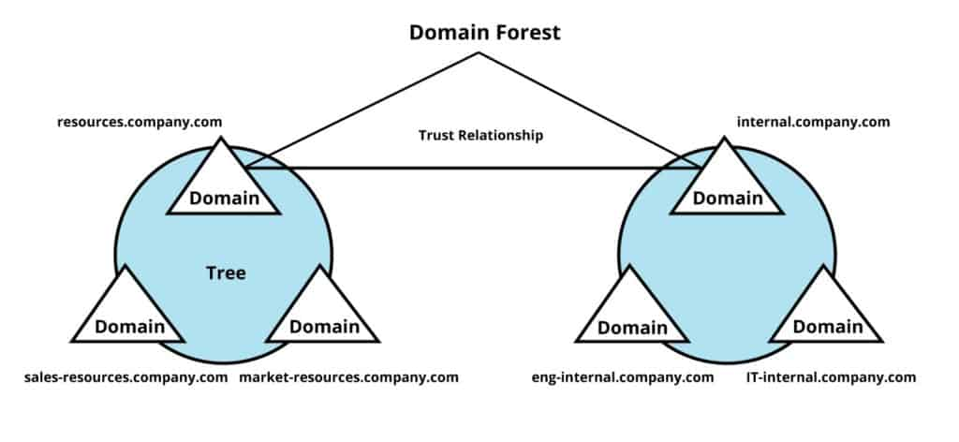

Active Directory Groups
Within Windows domain network environments, Active Directory Groups serve as a fundamental organizational tool that aggregates multiple objects, including users, computers, and contacts. By logically grouping these entities, you can better streamline their management processes and strengthen security protocols across the network simultaneously.

Purpose of Active Directory Groups
The primary advantage of utilizing groups lies in the ease of administration that they provide. Instead of handling each object individually – such as individual user accounts or computer systems – separately, administrators can manage them in a centralized and connected fashion. This approach not only simplifies the administrative workload but also allows for more efficient and consistent application of security policies and access permissions.

Permissions Management
Groups play an important role in permissions management and assignment within a domain. For instance, rather than granting access rights to each user or computer one by one, you can assign permissions to the entire group with one click. This means that any user or object added to the group will automatically inherit the permissions associated with that contained group. This capability is particularly useful in large organizations where managing individual permissions is unfeasible, cumbersome, and prone to human error.

Types of Groups in Active Directory
Active Directory categorizes groups into two main types, each serving their own distinct purposes:

Security Group
This type of group plays an important role for managing access to resources within a domain. Security groups can be used to grant or deny permissions to shared files, applications, and other network resources. By using security groups, you can easily enforce security policies via Group Policy Object (GPO) deployments effectively and ensure that only authorized users with justified business documentation, managerial approval with a need-to -know have access to requested sensitive information.

Distribution Groups
In contrast, distribution groups are primarily used for email communication purposes since Active Directory directly integrates with Microsoft’s Exchange SMTP for emailing services solution. They aid in the facilitation, establishment, and distribution of emails and messages to all domain members of the group without having to provide any access to resources. This type of group is not intended for security management but rather for enhancing internal and external communications within teams or departments.

Active Directory Group Scopes
Group Scopes refer to the distinct classification of security or distribution object groups within an AD network, which can be further categorized into three distinct types: Universal, Global, and Domain Local. Each of these group scopes has specific characteristics and functionalities that determine how they operate within a domain network’s structure.

Group Scope
The group scope is most crucial because it outlines the ranges and limitations of the group’s usability across the domain network. It indicates the extent to which the group can reach and interact with resources throughout the domain, tree, or forest entirely. This method of classification also plays a significant role in determining how grouped members are assigned and managed overall.

Global Groups
Global groups are designed to include objects such as user accounts and computer accounts that reside within the localized internal domain. These groups are particularly useful for granting access permissions to local networked resources when needed by users or computers from other domains, trees, or forests. Ideally, Global Groups serve as a connecting bridgehead that allows local domain resources and entities to be accessed by any domain-related network component from external domains, thereby facilitating cross-domain collaboration and resource sharing between interconnected and geographically dispersed teams.

Domain Local Groups
Domain Local Groups, on the other hand, have a broader membership capability as they can include objects from any domain within the network; however, the access privileges of these group members are restricted to resources that are located within just that local domain itself. This means that while Domain Local Groups can encompass a diverse set of members, their functionalities are limited to the resources available in their respective domains, making them ideal for managing access to local resources without extending permissions beyond established domain security boundaries.

Universal Groups
Lastly, Universal Groups are unique in that they can contain objects from various group scopes and any domain within the entire tree or forest. This allows for a more flexible and comprehensive membership structure, enabling Universal Groups to provide access to resources cross-joined domains. Members of Universal Groups can seamlessly access resources regardless of which domain they belong to, making them particularly advantageous for organizations that require wide-ranging collaborative efforts and resource sharing across differing domain boundaries.
It is important to note that understanding the distinctions among Global, Domain Local, and Universal Groups is essential for effective network management and security, as each group scope serves a very specific purpose in controlling access to resources across different levels of unique networks.

Components of the Active Directory Schema
The Active Directory Schema is a critical component of directory services that is used for managing permissions and access to domain networked resources. The schema defines the structure and rules that govern the types of objects that can be stored within the Active Directory environment.
To elaborate further on the key components mentioned:

Schema Object Classes
These are categories of objects that define the types of entities that can be created in Active Directory. Each object class carries specific characteristics and behaviors with it. For instance, the “User Class” allows for the creation of user accounts, while the “Group Class” pertains to groups of users. Each object class can inherit properties from other classes, allowing for sharing of resources and information in the hierarchical structure.

Schema Attributes
Attributes are the properties that are associated with each object class. For example, a user object might have attributes such as username, password, email address, and phone number. These attributes can be mandatory (required for the object to exist) or optional (not required). The schema specifies which attributes belong to which object classes and defines their data types, such as string, integer, or date.

Syntaxes
Syntaxes refer to the rules that govern how data is formatted and stored within the schema. Each attribute has a defined syntax that dictates what kind of data it can hold. For instance, an email address attribute might have a syntax that validates the format to ensure it follows standard email security and organizational conventions.

Control Access Rights
This aspect of the schema deals with permissions and security settings for accessing objects within Active Directory. It defines who can read, modify, or delete certain objects and attributes. Access control is essential for maintaining security and ensuring that only authorized individuals can interact with network sensitive information.
Overall, the Active Directory Schema serves as a blueprint for how data is organized and managed within the directory services architecture, enabling efficient administration and security of networked resources.

Active Directory Functional Domain Levels
Active Directory Functional Domain Levels are settings within the Active Directory Domain Services (AD DS) role that dictate the capabilities and features that are available to a specific domain or an entire forest. Each functional level corresponds to a particular version of Windows Server, which, in turn, determines the functionalities that can be effectively utilized within the Active Directory environment.
For instance, higher functional domain levels unlock advanced features such as improved replication, enhanced security protocols, and new administrative toolsets that streamline repetitive administration management tasks. Conversely, lower functional domain levels may restrict access to these innovations, limiting the effectiveness of the Active Directory setup.
When deploying AD DS, it is considered a best practice to configure the domain functional levels for both the domain and the forest to their maximum values, assuming all domain controllers within the environment support these varying levels. This approach ensures that you can leverage the latest advancements and improvements Active Directory has to offer, which can lead to enhanced performance, better overall security posture, and more efficient management and delegation of resources within the network. By staying current with domain functional levels, you are also ensuring compatibility with new applications and services that rely on the latest Active Directory features to function correctly.
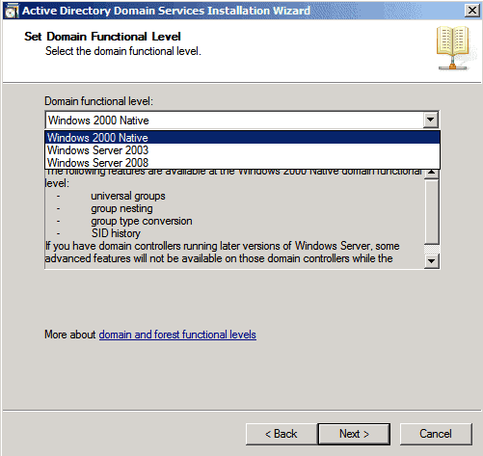

Active Directory Flexible Single Master Operation (FSMO) Roles
The Flexible Single Master Operation (FSMO – pronounced “Fizz-Mo”) roles are essential components of the Active Directory architecture that help to manage and maintain the integrity of the directory services across multiple Domain Controllers (DCs). These roles ensure that critical operations related to user authentication, authorization, and directory management can be performed without disruption, even if one or more DCs fail.
The separation of duties and responsibilities into distinct FSMO roles allows for a more organized and efficient management of directory services by distributing these roles among different DCs to provide redundancy and fault tolerance. Always a good thing to have. This also means that if Domain Controller goes offline for whatever reason, the other Domain Controller’s will continue to function normally, ensuring that users of the domain can still authenticate and access resources without any problems.
Within any Active Directory live environment, there exists five distinctive FSMO roles that serve different purposes altogether. These five FSMO roles include:

Schema Master
This is an enterprise-level FSMO role that is responsible for managing changes to the directory schema, which defines the structure of the domain directory data at large. There is only one Schema Master per forest, and it plays a crucial role in ensuring that schema modifications are propagated and replicated correctly throughout the forest.

Domain Naming Master
Another enterprise-level FSMO role, the Domain Naming Master, is responsible for managing the addition and removal of domains within an Active Directory forest. Like the Schema Master role, there is only one Domain Naming Master per forest, and it ensures that domain names are unique and properly configured.

Primary Domain Controller Emulator (PDCe)
This is a domain-wide FSMO role that acts as a primary point of authority within its respective domain. The PDC Emulator handles important tasks such as processing authentication requests, managing password changes, enforcing Group Policy Objects (GPOs), and providing network time synchronization for all DCs in the domain. It is vital for maintaining consistent authentication and security policies across entire domain enterprises.

Relative Identifier Master (RID Master)
The RID Master is a domain-level FSMO role responsible for allocating blocks of Security Identifiers (SIDs) to different DCs within the domain. Each SID is unique to an object in Active Directory, and the RID Master ensures that these SIDs are properly assigned to avoid conflicts and to maintain the integrity of established and assigned security permissions.

Infrastructure Master
This domain-level FSMO role is tasked with translating Globally Unique Identifiers (GUIDs), SIDs, and Distinguished Names (DNs) between differing domains. The Infrastructure Master helps maintain cross-domain references and ensures that objects from one domain can accurately references object in another domain.
Together, these FSMO roles play a critical role in providing the stability and reliability of Active Directory domain environments, ensuring that user authentication and directory management processes run smoothly across multiple replicating Domain Controllers.

Active Directory Recycle Bin
The Active Directory Recycle Bin serves as a protection mechanism for when those “Oh Crap” moments happen. The Active Directory Recycle Bin is a significant enhancement introduced in Windows Server 2012 R2 that provides a safeguard against accidental deletions within domain environments. This feature is particularly beneficial for organizations that manage many user accounts and other directory objects, as it allows for the recovery of deleted items without the need for complex recovery and restoration processes.
When an object, such as a user account, is deleted from Active Directory, it typically becomes permanently lost unless specific measures are taken to restore it; however, with the Active Directory Recycle Bin enabled, deleted objects are not immediately removed from the directory; instead, they are placed in a “recycle bin” state when they can then be easily recovered and restored back to normal operating state.
One of the key advantages of this feature is that it not only allows for the restoration of the deleted objects themselves, but also retains their associated attributes and properties assigned during initial provisioning of the user profile. This means that if a user account is deleted, it can be restored along with all of its original settings, such as group memberships, permissions, and any specific attributes that were configured and assigned during the initial account provisioning phase. This capability significantly reduces the administrative overhead and thwarts potential disruptions that could arise from having to recreate user accounts and reassign permissions manually.
Furthermore, the Active Directory Recycle Bin enhances overall operational efficiencies by providing a straightforward recovery and restoration mechanism. You can quickly restore deleted objects through the Active Directory Users and Computers (ADUC) Microsoft Management Console (MMC) or via PowerShell commands and cmdlets, minimizing downtime and ensuring that users can regain access to necessary domain resources without encountering excessive or extensive delays.
The Active Directory Recycle Bin is a vital feature for systems administrators who are utilizing Windows Server 2012 and later versions, as it offers a reliable solution for recovering deleted objects while preserving their attributes and relationships within the directory structure.

Active Directory Read-Only Domain Controllers (RODCs)

Read-Only Domain Controller (RODC) “Read-Only” Characteristic
Active Directory Read-Only Domain Controllers (RODCs) maintain a copy of the Active Directory (AD) database (ntds.dit) that is immutable, meaning that it cannot be modified directly. This characteristic is particularly beneficial in environments where security is a concern, such as branch offices or locations with less physical security implementations. By ensuring that the directory data cannot be altered, tampered with, or modified on the RODC, you can prevent unauthorized changes while maintaining the integrity of the replicated sensitive directory data information. Any updates or changes to the directory must be performed on a writable Domain Controller, which then replicates those changes back to the RODC.

Protection of RODC DNS Server
Further, the RODC can also function as a Domain Name System (DNS) server, which is necessary for resolving domain names to IP addresses within the network. By using RODC for DNS, you can enhance security by preventing unauthorized access to internal DNS record information. Since the RODCs DNS data is read-only, it minimizes the risk of DNS spoofing attacks or other malicious activities that could compromise network communications or jeopardize the entire Active Directory domain infrastructure. Additionally, this setup allows branch offices to resolve names locally without needing to connect to a writable Domain Controller over potentially insecure connections.

RODC Password Management and Protection
One of the most significant features of a RODC is its password management and protection capabilities. Its ability to manage user passwords securely takes a sometimes-over-burdened load off a system administrators’ plate. When a user logs in to a system that primarily authenticates against an RODC, their password is not stored on that RODC in a human-readable format. Instead, the RODC can cache passwords for user who authenticate against it, allowing for faster login times and reducing the need for constant communications with a writable Domain Controller sparing its memory to serve much larger, more pressing tasks. This feature also greatly enhances security since if an RODC is compromised, the attacker would not gain access to all domain user and entity passwords stored in a human-readable format.

RODC Administrative Role Delegation
The RODC allows you to delegate administrative roles without granting full control over the entire Active Directory environment. This means that local IT staff in branch offices can be given specific administrative rights to manage the RODC without having access to modify the entire AD database. This delegation helps maintain security and control, as it limits the “number of hands in the pot,” and limits the scope of what local administrators can or cannot do while still enabling them to perform necessary tasks such as managing user accounts or resetting passwords for local users and services.
These functionalities make RODCs valuable assets for organizations looking to enhance security and manageability in distributed environments.

Active Directory SYSVOL Folder
The Active Directory SYSVOL folder is a critical component of Active Directory in a Windows Server ecosystem. It serves as a shared directory on each Domain Controller (DC), which is a server that responds to security authentication requests within a Windows domain. The primary function of the SYSVOL folder is to store important data and information related to the Active Directory setup, such as Group Policy Objects (GPOs), and scripts that are critically necessary for the configuration, health, and management of the domain network.
One of the key features of SYSVOL is its ability to replicate this stored information across all domain controllers within their respective domains. This replication ensures that all DCs have consistent and up to date information, which is necessary for maintaining the integrity and reliability of the directory service at large. When changes are made in one DCs SYSVOL folder, those changes automatically propagate to other DCs, allowing for seamless updates and synchronization across the domain networks.
SYSVOL provides domain controllers with a dedicated location where they can access and share replicated data and information with one another. This shared access model is vital for various network functions, including security policy enforcement, user, and device authentication. By having a centralized and synchronized repository of critical data, SYSVOL plays the most important role in the overall functionality and performance of Active Directory domain environments.

Active Directory Services and Supporting Components
Active Directory provides a comprehensive suite of services designed to facilitate the management of user identities, permissions, and access control within a network environment. This suite of services is essential for organizations that need to maintain security and streamline access to various resources across their networks.
The specific Active Directory services available in Windows Server 2008 and Windows Server 2008 R2 include:

Active Directory Certificate Services (AD CS)
This service allows organizations to create and manage public key infrastructure (PKI) by issuing digital certificates. These certificates are used to secure communications, authenticate users, and safeguard data integrity.

Active Directory Domain Services (AD DS)
AD DS is the core service that provides the directory service functionality for Windows domains. It stores information about members of the domain, including devices and users, and manages authentication and authorization for access to resources.

Active Directory Federation Services (AD FS)
This service enables Single Sign-On (SSO) capabilities across different networks and applications. It allows users to authenticate once and gain access to multiple systems without needing to log in separately to each one.

Active Directory Lightweight Directory Services (AD LDS)
AD LDS provides a lightweight directory service that can be used for applications that require directory-enabled capabilities without the overhead of a full domain controller. It is ideal for applications that need to manage user accounts and authentication but do not require the full feature set of AD DS.

Active Directory Rights Management Services (AD RMS)
This service provides information protection technology that helps safeguard digital information from unauthorized use. It allows organizations to control how documents and emails are accessed, shared, and used by applying rights and policies.
These services collectively enhance an organization's ability to manage identities and secure access to its resources effectively, thereby improving overall operational efficiency and security posture.
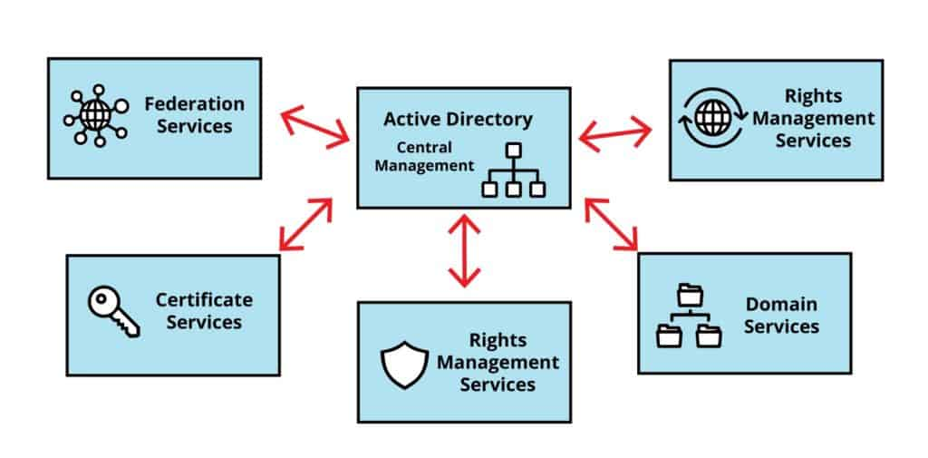

TL;DR Active Directory Services and Supporting Components
In a nutshell:
Active Directory Domain Services (AD DS) | - It is the most popular server role in Active Directory  - Responsible for the directory services that provide the technologies for storing directory data  - Make data available and manageable for all end-users
Active Directory Federation Services (AD FS) | - Is an identity management services solution  - Provide Single Sign-On (SSO) access control for web applications, websites, or multiple resources within a network  - Provide end-users flexibility ensuring they only need one set of credentials to access cross-domain-related resources  - Responsible for sending authentication claims rather than credentials
Active Directory Rights Management Services (AD RMS) | - Active Directory’s data access control solution  - Protect documents like emails, Office documents, and webpages, using encryption  - Enforce data access policies  - Deny/Permit access to specific users, and modifies read-only actions  - Encrypt and decrypt of all digital content
Active Directory Certificate Services (AD CS) | - Responsible for the generation and management of Public Key Infrastructure (PKI) digital certificates and signatures  - Set roles and policies to manage creating, managing, distributing, using, storing, and revoking certificates and public key sets  - Automate certificate provisioning and update Certificate Revocation Lists (CRLs)  - Leverage existing identity data to register new certificates  - Allow you to set AD group policies to enforce specific certificates for use on particular resources
Active Directory Lightweight Directory Services (AD LDS) | - An LDAP directory service for domain-specific applications  - Service is independent of domain limitations of AD DS (e.g., not bound to Active Directory, its domains, or forests)  - It can be run on any standalone server and provides its data store and the services for accessing it

Active Directory Domain Name Server (DNS)
The functionality of the Active Directory overall architecture is tightly related to the network protocol, Domain Name Server (DNS). This symbiotic relationship is crucial because Active Directory relies on and must have an interoperable and functional DNS server that is implemented to provide users, services and other domain-related entities with essential domain operations and services.
To run on your first Domain Controller, you will be required to install Active Directory and the DNS role. Installing these components is a fundamental step in setting up a network environment where users and resources can be efficiently managed. The domain controller serves as the primary backbone of Active Directory’s name-to-IP needs, while DNS ensures that all networked devices can locate, identify, and recursively resolve hostnames to IP addresses ensuring effective communications between all interconnected entities.
Active Directory cannot fully function to its potential without DNS, so hostname-to-IP address translations are a critical feature that must be correctly implemented to enable the Active Directory to better serve connected entities by fulfilling requests. This process, known as name resolution, allows users to access resources using easily memorable names instead of complex numerical IP addresses and unnaturally long FQDNs. For example, instead of typing an IP address to access a server (e.g., \\192.168.16.3\documents\) , a user can simply enter its hostname (e.g., \\aladdin\documents) , which DNS will then translate into the corresponding IP address behind the scenes.
All the clients in Active Directory use DNS for finding the domain controllers, and the domain controllers use it to talk back and forth with one another. This means that when a client device wants to authenticate or access networked resources within the environment, it first queries the DNS to locate the appropriate domain controller. Similarly, domain controllers communicate with one another using DNS to replicate information and maintain consistency across the network.
The DNS namespace is used across the public Internet, but the Active Directory namespace is only used inside the private local area network. The DNS namespace refers to the hierarchical structure that organizes domain names on the Internet, allowing users to navigate between different websites and services. In contrast, the Active Directory namespace is specifically tailored for internal network management, providing a structured way to identify and manage resources within an organization’s private local area network. This separation ensures that internal operations and processes can be handled securely and efficiently without interference from external entities.

Active Directory DNS Zones
A DNS Zone is a distinct segment of the Domain Name System (DNS) namespace that is primarily managed as a single entity. It serves as a container for a collection of multiple DNS records, which are essential for translating human-readable domain names (like www.example.com) into machine-readable IP addresses (like 192.0.2.1). By dividing the DNS namespace into zones, you can manage DNS records more efficiently while ensuring better redundancy and security.

DNS Resource Records (RR)
DNS Resources Records are the fundamental data elements within a DNS zone. Each record contains specific information that helps in resolving DNS queries. For instance, an “A” record maps a domain name to its corresponding IPv4 address, while an “AAAA” record does the same for IPv6 addresses. Other types of critical DNS records that Active Directory relies on for full operation include:

CNAME (Canonical Name)
Used to alias one domain name to another, allowing multiple domain names to point to the same IP address.

MX (Mail Exchange)
Specifies the mail server responsible for receiving email on behalf of a domain.

NS (Name Server)
Indicates which DNS server is authoritative for a particular zone.

DNS Zone Types

Active Directory-Integrated DNS Zone
This type of zone stores its data in the Active Directory database (ntds.dit), allowing for better integration with Windows network environments. It enables features like multi-master replication and enhanced security.

Primary Zone
The primary zone is where the original read-write copy of the zone data is stored. You can create, modify, and delete records in this zone.

Secondary Zone
A secondary zone is a read-only copy of a primary zone. It is used for redundancy and load balancing, allowing multiple servers to respond to DNS queries simultaneously.

Stub Zone
A stub zone contains only the necessary records to identify the authoritative name servers for another DNS zone. It helps in maintaining up to date information about the name servers without storing all the records.

Forward Lookup Zone
This type of zone is used to resolve domain names to IP addresses. It is the most common type of zone and is essential for normal DNS and Active Directory operations.

Reverse Lookup Zone
In contrast to forward lookup zones, reverse lookup zones resolve IP addresses back to domain names. They are useful for verifying the authenticity of an IP address to combat IP spoofing attempts.

DNS Zone Transfers
DNS zone transfers are processes that allow for the transfer of DNS data from one DNS server to another, ensuring that secondary servers have up to date information from primary authoritative DNS servers.

By understanding these components, and types of DNS zones, you can effectively manage domain name resolution and ensure that networks operate smoothly and securely.
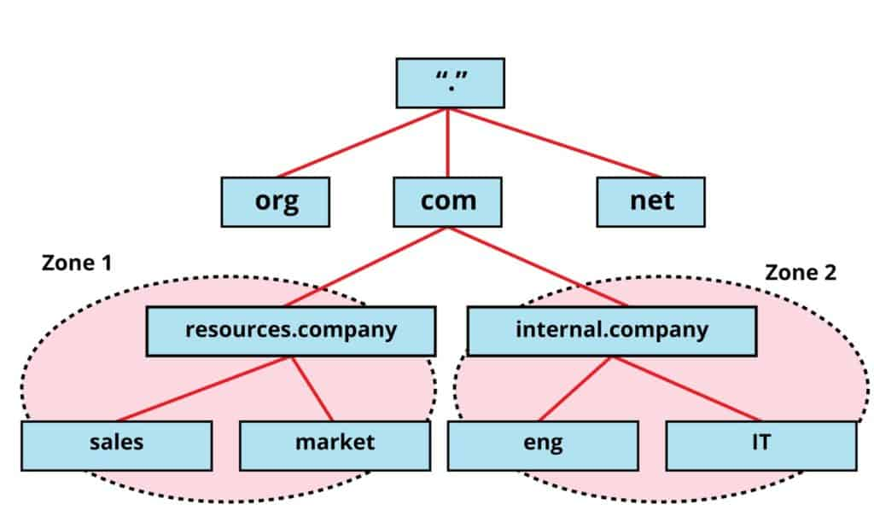

Active Directory Dynamic DNS (DDNS)

Dynamic DNS (DDNS) is a service that allows the automatic updating of DNS records in near-real-time as devices change their IP addresses. Unlike traditional vanilla DNS, which relies on static IP addresses that do not change, DDNS accommodates the needs of networks where devices frequently change their IP stack configurations (e.g., travel laptops). This is particularly useful in environments where Dynamic Host Configuration Protocol (DHCP) is used, as DHCP is like DNS little brother – it assigns IP addresses dynamically to devices on a network freeing up systems administrators from having to enter this information manually.

When a device, such as a computer or a server, connects to a network for the first time, it is assigned an IP address by the DHCP server. If the device disconnects and then later reconnects – perhaps moving from one local area network (LAN) to another – its IP address may change. In such cases, DDNS ensures that the DNS records are updated automatically to reflect this new IP address. This means that users or applications that are trying to reach the device using its hostname will still be able to do so without any manual intervention to update the DNS records.

In an Active Directory (AD) environment, clients rely on DDNS to keep their resources records up to date and current. When a client device registers with an AD domain controller, it uses DDNS to dynamically update its information in the DNS database. This process is crucial for maintaining seamless communications within the network, as it allows for the discover of services and resources without requiring static configurations, which, in turn, carry potential to introduce human error.

Overall, DDNS enhances network flexibility and reliability by ensuring that DNS records are always accurate, even as devise move and change their IP address stacks frequently.

Active Directory SRV (Service) Records

The DNS Service (SRV) record is a type of DNS record that specifies the location of servers for specific services within a network. It provides information about the hostname and port number of servers that provide certain services, enabling clients to locate and connect to these servers without any issue.

SRV records play an important role in the process of locating domain controllers. When clients, such as computers or users, need to find a domain controller to authenticate or access resources, they perform a query against the SRV records stored in the DNS database. These records indicate which servers are available at the time the query was run, to provide specific Active Directory-related services, such as LDAP (Lightweight Directory Access Protocol), or Kerberos-based authentication.

When a new domain controller is created in an Active Directory environment, it will automatically register its SRV records with the primary DNS server. This registration process ensures that the SRV records are updated and reflect the new domain controller’s presence on the network. As a result, clients can discover and connect to the new domain controller seamlessly, facilitating effective communications and resource access for all requesting clients within the domain.

Active Directory DNS Forwarders

DNS Forwarders in Active Directory are specialized servers that play a key role in the Domain Name System (DNS) infrastructure. Their primary function is to handle DNS queries for domain names that do not fall under the management of a specific domain DNS zone or cannot be resolved using local DNS records, and lookup servicing tools like whois.

When a DNS server receives a query for an address that it does not recognize or have any information about, it can utilize a DNS forwarder to efficiently manage the request; however, instead of attempting to resolve the query itself by querying the root DNS servers, which are the highest level of DNS servers on the Internet, the local DNS server can simply forward the request to a designated forwarder. This process significantly reduces the time and resources required to resolve unknown hostnames and domain names.

The use of DNS forwarders is particularly beneficial for organizations and networks that require efficient Internet access. By directing all queries for unrecognized Internet addresses to external DNS servers, such as those provided by Internet Service Providers (ISPs), or public DNS services like Google Public DNS or Cloudflare, networks ensure that users have quick and reliable access to external websites and services.

In sum, without a DNS forwarder in place, a local DNS server would be burdened with the task of having to query and re-query the root DNS servers for every unknown address, leading to increased latency, higher resource consumption and usage, and a less efficient resolution process for users who are seeking to access content over the public Internet.

DNS Aging and Scavenging of Records

DNS Aging and Scavenging is a crucial service that addresses the issue of stale resource records in the Domain Name System (DNS). Over time, as devices continue to connect and disconnect from a network, or as changes are made to network configurations, certain DNS records can become outdated. These stale records may have been created via Dynamic Domain Name System (DDNS) updates, where devices automatically register their IP addresses with the DNS server, or they may have been manually entered by network administrators.
The accumulation of stale records can lead to various domain network problems and anomalies, including confusion in name resolution, increased lookup times, and potential security vulnerabilities. To mitigate these issues, DNS aging and scavenging employ a systematic approach to automatically identify and remove these outdated records from the DNS database.

The process itself involves two key components: aging and scavenging.

DNS Aging Process

The DNS aging process is a method used by DNS servers (most notably in Active Directory environments) to automatically identify and delete outdated, abandoned, or stale dynamic resource records (like old IP addresses of decommissioned laptops or servers).

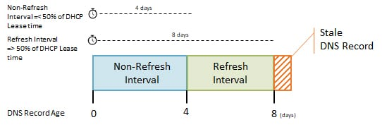
DNS aging workflow

The aging process uses the timestamp of a dynamically registered DNS record and two specific time intervals to determine if a record is stale:

1. Time Intervals

1.1 No-Refresh Interval
A specific period after a record is created or updated during which the client is not allowed to refresh its timestamp. This prevents unnecessary overhead and network traffic and directory replication if a device’s record hasn’t changed (Default: 7 days).

1.2 Refresh Interval
The period immediately following the No-Refresh interval during which the client is allowed to refresh its timestamp. If the client updates its record or renews its DHCP lease during this time, the timestamp is reset. (Default: 7 days).

2. The Aging Process Timeline

2.1 Creation
When a device joins the network, it dynamically registers its IP address and hostname in the DNS zone. The DNS server stamps this record with the current date and time.

Wait (No-Refresh)
For the duration of the No-Refresh interval, the device will not be able to update this timestamp, even if it reboots. (Note: If the IP address changes, it is considered updated and resets the timer).

3. The Window of Opportunity
Once the No-Refresh interval expires, the Refresh interval begins. During this window, the device (or DHCP server) will attempt to contact the DNS server to refresh the record’s timestamp.

4. Stale State
If the device is disconnected, turned off, or removed from the network before it can refresh its timestamp within the Refresh interval, the record will be flagged as stale.
NOTE:
Records can be refreshed during the stale period barring the record has not yet been deleted by the scavenging process, and, during this period, the record can be renewed in its stale state.

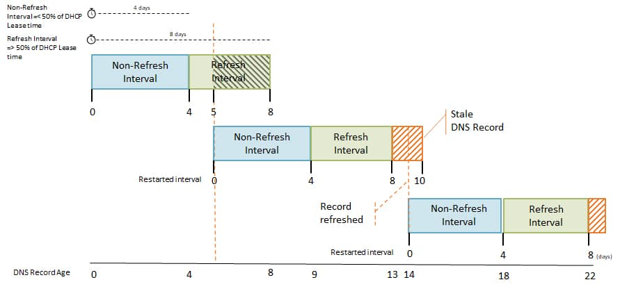
Workflow for resurrecting a stale DNS record for record renewal.

DNS Scavenging Process (The Cleanup)
DNS Scavenging is a process used in DNS management to clean up and remove stale or outdated DNS records that are no longer valid. This is particularly important for maintaining an accurate and efficient DNS database, as stale records can lead to resolution issues and other network problems.
When we say that scavenging is configured for the whole DNS server, it means that the setting for scavenging applies to all the DNS zones hosted on that server; however, each individual DNS zone must also have scavenging enabled for the process to take effect within that specific zone. This dual configuration ensures that you have control over which zones are subject to scavenging, allowing for flexibility depending on the needs of different parts of the network.
In the example below, I have set the scavenging interval to 4 days. What we can see here is that a stale record is deleted on day 11, and not exactly after 8 days (No-Refresh + Refresh Intervals).
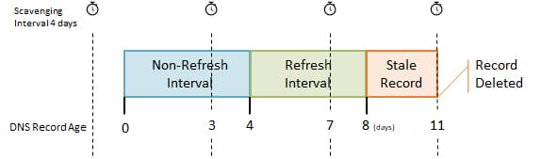
The scavenging interval refers to the frequency with which the scavenging process runs. It is specified independently of two other important intervals as mentioned above: the No-Refresh and Refresh intervals. The No-Refresh interval is the period during which a record cannot be refreshed; while the Refresh interval is the period during which a record can be refreshed before it so considered stale.
For example, if you set the scavenging period to 9 days, this means that the scavenging service will execute every 9 days (vice the default 7 days) to check for stale records; however, it does not imply that any record will be deleted exactly after the 9 day scheduled cleanup interval; rather, it will only be removed during the next scheduled scavenging run if it meets the criteria for being considered stale.
To decide when the next scavenging cycle will occur, you can utilize a PowerShell cmdlet known as Get-DnsServerScavenging. This command provides information about the current scavenging configuration and status, allowing you to effectively manage and watch the scavenging process within your DNS infrastructure.

1. Get-DnsServerScavenging

2.

3. # Result

4. NoRefreshInterval : 7.00:00:00

5. RefreshInterval : 7.00:00:00

6. ScavengingInterval : 7.00:00:00

7. ScavengingState : True

8. LastScavengeTime : 4/11/2025 4:27:43 AM

9.

10. # Or let PowerShell calculate the next day:

11. $scavenge = Get-DnsServerScavenging

12. (Get-Date($scavenge.LastScavengeTime)).AddDays($scavenge.ScavengingInterval.days)

13.

14. # Result

15. Tuesday, April 18, 2025 4:27:43 AM

DNS aging only identifies the stale records; it does not delete them. The actual deletion is handled by its companion process, Scavenging.
Two main considerations to note:
- Scavenging operates on a recurring schedule (e.g., every 7 days).
- When it runs, the DNS server checks all dynamic records. If the current time exceeds the record’s timestamp combined with both the No-Refresh and Refresh intervals, the record will be purged from the DNS zone.
NOTE:
An Important Note on Static DNS Records
Records added manually by a network administrator are given a timestamp of 0. This tells the DNS aging and scavenging processes ignore them, ensuring they remain in the zone indefinitely.

DNS scavenging is the actual cleanup mechanism that removes these stale records from the DNS database, ensuring that only current and valid entries remain.

DNS Tombstoning Process
The DNS Tombstoning process is a two-step deletion method used for cleaning up outdated or stale dynamic DNS (DDNS) records. It logically marks records as inactive by setting a dNSTombstoned attribute to TRUE and clearing the associated IP entry, preventing them from being immediately purged.
So, what is the difference between DNS scavenging and DNS tombstoning if they both appear to execute the same cleanup task?

Differentiating Between DNS Scavenging and DNS Tombstoning
DNS scavenging and DNS tombstoning are two distinct phases in the lifecycle of managing stale, outdated Dynamic DNS (DDNS) resource records, most commonly within Active Directory-integrated DNS environments. The funda
The fundamental difference, however, is that tombstoning marks a DNS record as “ready for deletion,” while scavenging is the actual process of physically purging (deleting) those marked records from the DNS database.
DNS tombstoning acts as a holding or “pending deletion” state for stale records. How this works is that when a DNS record is not refreshed during or within its designated time constraints (the No-Refresh and Refresh intervals), it is considered “stale.” The DNS server updates the record’s internal attribute, marking it as a tombstone (e.g., dNSTombstoned = TRUE).
Simply speaking, the DNS tombstone process serves as a type of security safety buffer. If a device was temporarily offline but is about to reconnect back to the network, this state will prevent the immediate deletion of records that may still be valid at that point. It does not remove the record from the DNS table. The record will still exist for you to access; however, the DNS server will maintain the understanding that the record is still expired.
To understand exactly how scavenging works in relation to the default 7-day schedule, it helps to look at the process as an automated garbage collector. The scavenger does not evaluate the health of your live network; it simply executes a calculated math formula on a strict timer.

Active Directory-Integrated DNS vs. Commercial Windows DNS
Active-Directory-Integrated DNS is a specific, highly secure deployment method of the broader Commercial Windows DNS (the Microsoft DNS Server role). While they both use the same DNS server software, how they store and replicate data differs fundamentally.
The table below visualizes the key differences between both DNS features.
Feature | Standard (Commercial) Windows DNS | Active Directory-Integrated DNS
Data Storage | Stored in local text files (.dns files) on the server’s hard drive | Stored directly inside the Active Directory database (ntds.dit)
Replication | Uses standard DNS zone transfers (primary to secondary server) | Uses native, multi-master Active Directory replication
Fault Tolerance | Requires configuring primary and secondary servers | Every Domain Controller is a writable primary DNS server
Security | Supports basic access control lists (ACLs) on zones | Support secure dynamic updates and strict AD permissions

Choosing the Most Appropriate DNS for Your Active Directory Domain Environment
AD-Integrated DNS is the Microsoft-recommended best practice for internal corporate networks utilizing Active Directory. Because it’s so tightly woven into Active Directory, replication becomes seamless across all Domain Controllers, and it eliminates the need for systems administrators to manage manual DNS zone transfers.
However, on the other hand, standard Windows DNS is used for standalone server environments, external-facing networks, or environments where DNS management is intentionally separated from Active Directory.

Active Directory DNS Root Hints
Root Hints are vital DNS components that serve as a reference for DNS servers when they encounter queries for hostnames that they cannot resolve locally. These files contain a list of resource records, specifically the names and IP addresses of authoritative DNS servers that are responsible for the root zone of the DNS hierarchy.
The root zone is the top-level domain in the DNS structure and holds the information necessary to direct queries to the appropriate top-level domain (TLD) servers, such as those for .com, .org, .net, and others. By using DNS Root Hints, a DNS server can initiate a query process that ultimately leads to the resolution of a hostname, even if it does not have the information readily available in its own cache or configuration.
In contrast to Root Hints, DNS forwarders are another mechanism used to resolve external hostnames. As described above, and to reiterate here, a DNS forwarder is a server that is configured to forward DNS queries it cannot resolve on its own to another DNS server (often an external one). The key distinction between Root Hints and DNS forwarders lies in their functionalities: Root Hints provide a comprehensive list of authoritative name servers specifically for the root zone, which helps guide the resolution process from the top down. On the other hand, DNS forwarders rely on a predefined list of DNS servers that can assist with resolving queries, but do not inherently contain authoritative information about the root zone or any specific domains.
In sum, Root Hints are a critical part of overall DNS resolution process as it offers a foundational reference point, while DNS forwarders serve as intermediaries that facilitate query resolution through external servers.

Active Directory and Dynamic Host Configuration Protocol (DHCP)
The Dynamic Host Configuration Protocol (DHCP) is also a critical network management protocol that facilitates the dynamic allocation of IP addresses and other essential TCP/IP stack configuration parameters. This protocol is designed to streamline the process of assigning IP addresses to devices (referred to as DHCP clients) on a network, ensuring that each device can communicate effectively without the need for manual configuration.
The operation of DHCP relies heavily on the presence of a DHCP server, which is responsible for managing a pool of available IP addresses and distributing them to clients as they connect to the network. In addition to IP addresses, the DHCP server also provides other important information, such as the default gateway (which allows devices to communicate outside their local network) and DNS server information (which helps resolve domain names into IP addresses).
One of the key components of DHCP is its interaction with Active Directory. Active Directory relies on the DHCP server to respond to client requests efficiently, ensuring that devices within the network can seamlessly obtain the necessary configurations to join and operate within the domain.
When a DHCP client connects to a network, it initiates this process by broadcasting a DHCP discovery message. This message is a request for available DHCP servers in the vicinity. Upon receiving this broadcast discovery message, the DHCP server will respond with a DHCP offer, which includes an available IPv4 or IPv6 available address from its IP allocation resource pool, along with other configuration details. This exchange is a key part of the DHCPs’ process, allowing devices to quickly and automatically receive the network settings they need to be able to function on the network and within the domain properly.
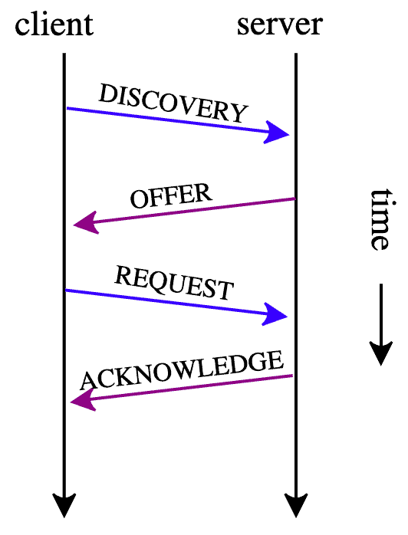

DHCP Scope: The Brains of the Operation
The DHCP Scope is a vital component of the Dynamic Host Configuration Protocol (DHCP), which is used to automate the process of assigning IP addresses and their TCP/IP stack configuration details and parameters to devices on a network. A DHCP scope defines a specific range of IP addresses that can be allocated to devices, known as DHCP clients, within a particular network or subnet.

DHCP Scoping Options
The DHCP scope contains several key elements which are worth mentioning:

1. The IP Address Range
This includes a starting IP address and an ending IP address, along with a subnet mask that determines the network’s overall size. The subnet mask is crucial because it helps you to identify which portion of the IP address refers to the network and which part refers to the host. For example, if the starting IP is 192.168.1.1 and the ending IP is 192.168.1.100, the subnet mask might be 255.255.255.0, allowing for 100 usable addresses in that range.

2. IP Address Exclusion
Within a DHCP scope, there may be certain devices that require static IP addresses, such as printers or servers, which cannot change over time. To prevent conflicts where two devices might try to use the same IP address, these static IP addresses must be excluded from the DHCP scope. This exclusion ensures that the DHCP server does not assign these specific IP addresses to any other devices on the network.

3. Lease Duration
The lease duration specifies how long a DHCP client can use a given IP address before it must renew its lease or return the address back to the pool of available addresses. For example, if the lease duration is set to 24 hours, the client will keep that IP address for one day before needing to request it again. This mechanism helps manage the limited pool of IP addresses efficiently, ensuring that they are not tied up indefinitely by devices that are no longer connected to the domain network.

4. Other Settings
In addition to just assigning IP addresses, a DHCP scope can also be configured with additional specific parameters that help DHCP clients connect to the network properly. These settings can include specifying the default gateway, which is necessary for routing internal network traffic outside of the local subnet; DNS servers, which resolve domain host names to IP addresses (rDNS, reverse DNS servers do exactly what their name says); and WINS (Windows Internet Naming Service) configurations, which assists with name resolution in Windows networks.
Overall, the DHCP scope plays a critical role in network IP address management by facilitating efficient IPv4 and IPv6 address allocation and providing essential network configuration information and parameters to devices as they join and rejoin the network.

DHCP IP Address Pools and Active Directory
The DHCP Scope, including exclusions and allowances, determines a DHCP servers available IP address pool.
The DHCP Scope refers to the range of IP addresses that a DHCP (Dynamic Host Configuration Protocol) server is authorized to configured to manage and assign devices on a network. This range is most important for ensuring that devices can bi-directionally communicate in an effective manner. If hardening measures have been applied to the DHCP Scope and server itself, controls would aim to block or thwart interception or Man-in-the-Middle (MitM) attacks where an unauthorized actor would sniff the network for DHCP traffic and capture packets essentially hijacking the legitimate session leaving the other communicating party to believe that it is still communicating with the original recipient. Within this scope, there also may be exclusions, which are specific IP addresses or ranges even classes of addresses that the DHCP server will not assign to clients. These exclusions are often set aside for devices that require static IP addresses, such as a VPN server, or a Domain Controller, which need consistent static IP addressing for reliable availability, communication, and access.
The DHCP server, with its already established DHCP scope in place, starts to assign IP addresses to a select bunch of devices from its pool of available addresses.
Once the DHCP scope is defined, the DHCP server will begin the process of allocating IP addresses to the clients as they start to connect to the network. When a device, such as a computer or smartphone, requests an IP address, the DHCP server will select an available IP address from the predefined pool within the scope and will assign it to the device automatically. This assignment process typically involves a lease expiry period, which specifies how long the device can use that IP address before it must renew the least or request a new address altogether.
When a DHCP client leaves or disconnects from the network, the IP address is returned to the pool of available IP addresses and is available for the next client when it connects.
If a device disconnects from the network, or is turned off, the IP address that it was using becomes available again for reassignment. This is an important feature of DHCP, as it allows for efficient use of IP addresses and ensures that they can be reused by other devices that may join the network later. The process of returning an IP address to the pool can happen automatically when the lease expires or it can be initiated by the DHCP server if it detects that a device is no longer connected.
If a pool has exhausted all its available IP addresses, the size of the IP address range must be manually expanded to allow for more IP addresses.
In situations where all available IP addresses within the defined DHCP scope have been assigned and there remain devices that are attempting to connect to the network to retrieve an address, the pool is considered exhausted. To accommodate more devices, a network administrator may need to expand the size of the IP address range within the DHCP scope. This can involve adjusting the starting and ending IP addresses of the range to include more addresses or creating additional scopes, if needed, and as necessary. Expanding the pool of available IP addresses will ensure that there are sufficient IP addresses for all devices on the network, preventing connectivity issues while facilitating smooth network operations in the meantime.

DHCP Reservations
A DHCP (Dynamic Host Configuration Protocol) server can be configured to reserve and permanently assign a specific IP address to a particular client requesting one. Unlike standard dynamic leasing, where addresses are temporarily handed out from the available pool of IP addresses and reclaimed when no longer needed, a reservation creates a fixed binding between a client’s hardware identifier and its IP address.
When a reservation is configured, the DHCP server will mark that address as unavailable for general lease assignments within its address pool. The server then will monitor incoming DHCP requests and will check the client’s MAC (Media Access Control) address – a unique hardware identifier burned into the device’s Network Interface Card (NIC). Only the client whose MAC address matches the reservation record will receive the reserved IP address. Any other device requesting an address from the pool will be given a different, dynamically assigned one.
This mechanism effectively eliminates the risk of IP address conflicts, which can occur when two devices inadvertently claim the same address – a situation that causes connectivity issues, loss of network access, dropped packets, and difficult-to-diagnose network problems. By ensuring that a particular device always receives the same IP, reservations provide both stability and predictability.
DHCP reservations are commonly deployed for network infrastructure devices and other systems where a consistent, unchanging IP address is important for reliable access and administration. Typical use cases include:
- Network printers – so workstations can reliably find them without reconfiguration.
- Servers – ensuring internal services remain reachable at known addresses.
- VIP workstations – for critical users where consistent network access is required.
- IP phones and access points – where static addressing simplifies management.
- Monitoring systems and cameras – where IPs are hard-coded into surveillance or logging tools.
- PAWs and SAWs – where these secured, hardened and locked down administrative machines keep the same IP address so that they align with internal extended access control lists in routers and firewalls.
DHCP reservations offer the best of both worlds: the centralized management and ease of DHCP, with the permanence of static IP addressing.

DHCP Filtering in Active Directory Environments
DHCP filtering is a security feature within the Windows Server DHCP role that provides access control at the network infrastructure level. When integrated with Active Directory Domain Services (AD DS), it operates as part of the broader identity-aware network access strategy, helping you enforce which devices are permitted to obtain IP configurations from the organization’s DHCP servers.
Through the DHCP administrative console or PowerShell (e.g., the Add-DhcpServerv4Filter cmdlet), you can create two types of filtering lists – Allow and Deny – each keyed to client MAC addresses. These lists are stored in the DHCP server’s registry or in the domain-joined DHCP database and can be centrally managed alongside other DHCP scopes and options. Filtering operates as follows:
- Allow List (Whitelist): Only clients whose MAC addresses appear in the allowlist are granted an IP lease. All other devices are silently ignored. This is a strict, closed-network model used in high-security zones.
- Deny List (Blacklist): Clients on the denylist are explicitly blocked from receiving an IP address, while all other clients proceed with normal DHCP processing. This is a lighter touch, useful for banning known rogue devices without affecting the rest of the network.

When a DHCP request arrives, the server will check the client’s MAC address against the relevant filter before consulting the scope for an available lease. If the request is denied – either because the client is on the denylist or absent from the allowlist – the server will drop the request without responding leaving you sitting there waiting – for nothing. The client, receiving no DHCPOFFER, will eventually time out and fall back to an Automatic Private IP Address(ing) (APIPA) address (169.254.x.x), effectively isolating it from the managed production environment.

Active Directory Integration Benefits
DHCP servers within an Active Directory domain benefit from centralized management through the DHCP Management Console or Group Policy, which enables you to apply uniform filtering policies consistently across multiple scopes and sites from a single vantage point. This eliminates the need to configure each DHCP server individually and ensures that access control rules remain synchronized across the entire domain enterprise.
From an audit and compliance standpoint, filtering events are automatically recorded in the DHCP audit log and can be forwarded to the Windows Event Viewer for centralized collection and analysis. This provides you with a clear time-stamped record which specifies which specific devices were granted or denied network access, supporting both ongoing compliance monitoring and post-incident forensics investigations.
Role-Based Access Control (RBAC) further strengthens the security posture by allowing DHCP filtering configuration to be delegated only to specific administrative groups, for example, restricting modification privileges to the DHCP Admins group while preventing unauthorized changes by other personnel. This aligns with the principle of least privilege and reduces the risk of accidental misconfigurations or malicious tampering.
In Active Directory environments, DHCP filtering can also be integrated with broader network access protection solutions and switch-level 802.1X authentication to create layered security defenses, or defense in depth. In this architecture, filtering operates at the DHCP layer as a first line of defense, blocking unauthorized devices from being able to plug and play into the network and receive an automatic IP address before they even reach the authentication stage – providing protection even when lower0layer security mechanisms are not yet in play, or available.

Common Use Cases in Active Directory Networks
DHCP filtering addresses several real-world security and operational challenges in enterprise Active Directory FICAM networks. It can prevent unauthorized employee or guest devices from obtaining an IP address on the corporate VLAN (Virtual Local Area Network), ensuring that only sanctioned equipment gains access to internal resources. When a rogue device is detected during routine security sweeps, its MAC address can be quickly added to the denylist to block it at the DHCP level without requiring physical or manual intervention. In more sensitive network segments, such as lab environments, Out-of-Band (OOB) networks, DMZs (Demilitarized Zones), air-gapped, or isolated classified network zones, an allow-only filter can be deployed to restrict DHCP access to a pre-approved set of devices. Organizations can also enforce a “known device only” policy, requiring every device to be registered with the helpdesk before its MAC address is added to the allowlist – creating a formal onboarding process for network access.
DHCP filtering thus serves as a lightweight, but effective first line of defense at the network edge – particularly valuable in Active Directory environments where device identity and policy enforcement are already central pillars of the entire security model.

DHCP MAC Address Stickies
MAC Address Stickies is a feature on certain network switches (most associated with Cisco Catalyst switches running IOS or similar firmware) that allows you to permanently pin an MAC address to a specific switch port.
Normally, a switch automatically learns MAC addresses dynamically – when a device broadcasts its presence by sending traffic using a particular port, the switch will record that MAC-to-port mapping int its MAC address table and ages it out after a period of inactivity. A MAC address sticky changes this behavior altogether: the switch will instead convert the dynamically learned MAC addresses on a port into secure, persistent entries that are saved to the switch’s running configuration and do not age out.
Once a MAC address is “stuck” (made sticky) on a port, only that specific device can communicate through that port. If a different device tries to connect to that switchport, the switch will either immediately block it or trigger a security violation which, in turn, will automatically shut the port down and can only be brought back up by an administrator who will manually clear the sticky port violation thus reinstating network access for that device to which the MAC address is mapped to that specific switch port.

How to Configure MAC Address Stickies
MAC address stickies are configured as part of port security on a switch interface (and, in case you are wondering – yes, there exists a STIG for switch port hardening). Below, the basic workflow of setting up a MAC address sticky is described below.
  - Enter interface configuration mode for the port you want to secure with a sticky:
Switch(config)# interface gigabitEthernet 0/1
Or, by entering the short-hand version of the command:
Switch(config)# int gi 0/1
Which does the same thing as the command above.

Quick Detour: Understanding the Differences Between DNS, WINS, DDNS, NetBIOS, mDNS, and LLMNR
To clarify:
- DNS – Domain Name System
- WINS – Windows Internet Naming System
- NetBIOS – Network Basic Input/Output Service
- mDNS – Multicast DNS
- LLMNR – Link-Local Multicast Name Resolution

All networking protocols heavily used within Active Directory domain environments at the same time primarily used for domain local and external name resolution and recursion (translating easy-to-red computer names into numerical IP addresses), and while they all serve a similar foundational purpose, they differ in where they operate, their scale, and how modern they are. As an enterprise defender, it is necessary for your foundational knowledge to understand the differences between these seemingly copycat, or functionally repetitive network protocols.

.1.11 DNS (Domain Name System)
- What It Is: The primary phonebook of the Internet. It maps human-readable domain names (e.g., www.google.com) to IP addresses (e.g., 142.250.190.46).
- How It Works: It relies on a hierarchical, centralized (or distributed) database of networked DNS servers. It is used for both global internet browsing and local area corporate networks.
- Synonym / Modern Standard: [Unicast DNS] (since queries are sent to one specific, known server).

B.2.22 DDNS (Dynamic DNS)
- What It Is: An extension of standard DNS that automatically updates IP addresses in near-real-time.
- How It Works: In traditional DNS, updating records requires manual changes. With DDNS, when a device’s IP address changes (e.g., a home router or a DHCP client), it immediately notifies the DNS server to update its corresponding name.

3.33 NetBIOS (Network Basic Input/Output System)
- What It Is: A legacy Microsoft protocol from the 1980s used to identify and communicate with computers on a Local Area Network (LAN).
- How It Works: NetBIOS names are flat (e.g., AccountingPC) rather than hierarchical like DNS. It resolves names by broadcasting messages to every machine on the local subnet to ask, “Who has this name?”

..4.44 WINS (Windows Internet Naming Service)
- What It Is: Microsoft’s legacy system designed to improve NetBIOS.
- How It Works: Instead of broadcasting requests to every single computer on a local network, WINS uses a centralized server. Computers register their NetBIOS names with the WINS server, and other computers query the WINS server directly. It is mostly obsolete in many of today’s modern environments.

.5.55 mDNS (Multicast DNS)
- What It Is: A decentralized, local version of DNS built for home or small networks (zero-configuration networking).
- How It Works: When a computer needs to find another device (like a printer or another computer) on the same local network, it will multicast the request to all devices using the .local domain. The device that rightfully or legitimately owns the name will answer directly.

.6.66 LLMNR (Link-Local Multicast Name Resolution)
- What It Is: A Microsoft fallback protocol used when standard DNS resolution fails on a local network.
- How It Works: If you mistype a computer name or a server name in Windows File Explorer and DNS fails, LLMNR multicasts a query to all computers on the local subnet asking if anyone recognizes the requested name.

DNS and Equivalent Protocol Summary Cheat Sheet
Protocol | Scope | Type of Lookup | Primary Environment | Status in Modern Networks
DNS | Global / Local | Unicast | Internet & Corporate | Essential
DDNS | Global / Local | Unicast (Updated automatically) | Home / Corporate Dynamic IPs | Essential
NetBIOS | Local Subnet | Broadcast | Old Windows Networks | Obsolete / Security Risk
WINS | Local / Wide Network | Unicast | Legacy Windows Networks | Obsolete
mDNS | Local Subnet | Multicast | Home / Apple Ecosystem | Active & Common
LLMNR | Local Subnet | Multicast | Windows Subnets (Fallback) | Active, but recommended to disable due to security risks

Malicious Artificial Intelligence (AI) and Machine Learning (ML) for Active Directory Attacks and Defensive Countermeasures

Malicious (Offensive ) AI and ML
Malicious AI and ML are primarily acting as “force multipliers” in Active Directory attacks. Rather than executing fully autonomous, sentient cyberattacks, threat actors leverage Large Language Models (LLMs) to lower technical barriers, accelerate attack compromise phases, and employ machine learning algorithms to bypass implemented security behavioral defenses.

The Weaponized Generation of AI and AD

Automated Reconnaissance
Attackers leverage LLMs to rapidly scan leaked or scraped Active Directory sensitive documentation, identify structural misconfigurations, and formulate precise LDAP queries (such as those used with the ADFind tool) without requiring any type of deep knowledge or expertise in Active Directory.

Hyper-Realistic Phishing: Long Gone Are The Days Where The First Clue to a Phish Was For Users to Spot Misspelled Words As Red Flags
Generative AI allows attackers to now precisely construct grammatically correct and flawless phishing emails or deepfake voice/audio combinations. These are used to bypass user awareness training to essentially coerce, manipulate, deceive, or trick unsuspecting employees into authorizing such activities like wire transfers or divulging initial access credentials when there is no warranted business justification, or need-to-know.

Malware Generation and Debugging
Attackers use AI to generate, obfuscate, and iterate malicious payloads – such as script-based loaders and the stealthiest of backdoors – all designed to seamlessly blend in with enterprise network traffic while executing post-exploitation commands against the domain network.

AI-Accelerated Credential Theft and Offline Cracking

Accelerated Hashes
The AI boom has made powerful hardware (like clustered GPUs) widely available and cheap to rent for just a few dollars an hour. Attackers combine this computing power with AI-driven models that learn human password patterns, can quickly create and produce complex sets of wordlists (much faster than a human can look create and produce one), vastly reducing the time needed to crack weak to moderately complex Active Directory credentials.

Adversarial Machine Learning (Attacking Defensive AI)
Defenders increasingly rely on AI-driven User and Entity Behavior Analytics (UEBA) to detect anomalies in Active Directory domains and networks; however, attackers quickly counter this with Adversarial Machine Learning (AML) through activities, such as:
Model Evasion. Attackers test malware samples and variants against evasive ML classifiers (e.g., Microsoft Defender for Identity (MDI)) in their own labs, mutating code just enough to avoid security countermeasures in place.
Data Poisoning. Threat actors leverage ML to inject misleading or false information into datasets that defenders use and trust to train their security models, degrading the model’s algorithmic capability to hinder it enough to not recognize legitimate AD anomalies in near-real-time.

Large Language Model (LLM) Jacking
A prevalent threat involving AI is LLM Jacking. This is a new attack where attackers first compromise a set of API (Application Programming Interface) keys, or cloud service accounts, or enterprise AI implementations to hijack linked cloud or on-premises infrastructure. LLM Jacking allows attackers to leverage expensive computing power to train their own malicious models or will resell compromised access on the dark web.

